[ PLACEHOLDER — Insert University of Colombo crest here ]
WEDDING AND EVENT MANAGEMENT SYSTEM
FOR
EVENT SERVICE PROVIDERS (EVENTPRO)
<CANDIDATE'S INITIALS AND LAST NAME>
<Index Number>
Name(s) of the supervisor(s): <Supervisor Name>
<Submission Month> <Submission Year>
[ PLACEHOLDER — Insert BIT logo and UCSC logo here ]
This dissertation is submitted in partial fulfilment of the requirement of the
Degree of Bachelor of Information Technology (External) of the
University of Colombo School of Computing

Declaration
I certify that this dissertation does not incorporate, without acknowledgement, any material previously submitted for a degree or diploma in any University/Institute, and to the best of my knowledge and belief, it does not contain any material previously published or written by another person or myself except where due reference is made in the text.

Signature of Candidate: ............................................ Date: ....................

Name of Candidate: ............................................

Countersigned by:

Signature of Supervisor(s)/Advisor(s): ............................................ Date: ....................

Name(s) of Supervisor(s)/Advisor(s): ............................................

Abstract
Wedding and event service providers in Sri Lanka — hotels, banquet halls, and independent event-planning companies — still coordinate the majority of their operations through telephone calls, paper diaries, and disconnected spreadsheets. Venue availability is tracked in physical booking books, quotations are prepared manually in word processors by editing older documents, and payment installments are reconciled by hand. This manual process leads to double bookings, lost inquiries, delayed and inaccurate quotations, untracked outstanding balances, and an inability for management to obtain a consolidated, real-time view of revenue and upcoming events.
This dissertation presents the design, implementation, and evaluation of EventPro, a web-based Wedding and Event Management System that automates the complete event-business workflow: public inquiry capture with automatic client normalization, venue and package administration with guest-count-based pricing, quotation generation with a controlled status workflow and PDF export, booking lifecycle management with real-time venue availability checking that prevents double bookings, installment-based payment recording through both manual channels and the PayHere online payment gateway with cryptographically verified callbacks, vendor and staff task coordination, a customer self-service portal, and management reporting with date-range filtering and PDF export. The system is architected as a white-label, multi-tenant platform, so that a single deployment serves many independent event businesses, each with its own branding, users, and strictly isolated data.
The system was developed using PHP 8.2 on the Laravel 12 framework, with a Vue 3 and Inertia.js single-page administration application styled with Tailwind CSS, backed by a MySQL relational database (SQLite in development). An iterative and incremental development model was followed across five planned increments. The solution was verified through unit, integration, and system testing using PHPUnit — including dedicated automated tests for tenant data isolation, payment integrity, and security headers — and validated through User Acceptance Testing with representative coordinators and customers. Testing confirmed that all functional requirements, including role-based access control and double-booking prevention, were satisfied, and UAT participants rated the system's usefulness above four out of five. The system materially reduces administrative effort and provides management with accurate operational visibility. Future enhancements include time-slot-level availability, SMS notifications, a native mobile application, and AI-assisted demand forecasting.

Acknowledgements
I would like to express my sincere gratitude to my supervisor, <Supervisor Name>, for the continuous guidance, constructive feedback, and encouragement provided throughout every phase of this project. I am grateful to the University of Colombo School of Computing and the BIT programme coordinators for the knowledge, resources, and structured project framework that made this work possible. I extend my special thanks to the owner and coordinating staff of the event-management business who generously gave their time for requirement interviews, workflow observation, and user acceptance testing, and to the volunteers who evaluated the customer portal. Finally, I thank my family and friends for their patience, understanding, and unwavering support during the many months of this project.

Table of Contents
(All UML diagrams and wireframes are embedded; only the screenshot figures remain as placeholders. After inserting the screenshots, right-click the table of contents below and choose “Update Field → Update entire table” so headings and page numbers refresh automatically. Update the page numbers in the Lists of Figures and Tables in the same manner.)

List of Figures
Figure 1.1: Work Breakdown Structure of the Project 5
Figure 2.1: Flowchart of the Existing Manual Event-Management Process 8
Figure 3.1: Layered System Architecture of the Proposed System 20
Figure 3.2: Use Case Diagram for the Proposed System 21
Figure 3.3: Class Diagram for the Proposed System 23
Figure 3.4: ER Diagram for the Proposed System 24
Figure 3.5: Sequence Diagram — Booking Creation with Availability Check 27
Figure 3.6: Sequence Diagram — Online Payment through PayHere 28
Figure 3.7: Activity Diagram — Quotation-to-Payment Workflow 28
Figure 3.8: Wireframe — Tenant Admin Dashboard 30
Figure 3.9: Wireframe — Booking Creation Form 30
Figure 3.10: Wireframe — Client Self-Service Portal 31
Figure 4.1: Project Module / Folder Structure 34
Figure 4.2: GitHub Repository and Commit History 38
Figure 5.1: PHPUnit Automated Test Execution Output 44
Figure 5.2: Summary of User Acceptance Testing Feedback 46
Figure A.1: Application Installation and Setup Commands 52
Figure B.1: Login Interface 54
Figure B.2: Booking Calendar View 54
Figure B.3: Quotation Builder 55
Figure B.4: Client Portal Home Page 56
Figure C.1: Revenue Report with Date-Range Filtering 57
Figure C.2: Outstanding Balances Report 58

List of Tables
Table 2.1: Similar Systems Comparison Matrix 11
Table 3.1: Use Case Description — Create Booking 22
Table 3.2: Data Dictionary — bookings Table 25
Table 3.3: Data Dictionary — payments Table 26
Table 3.4: Data Dictionary — quotations Table 26
Table 3.5: Mapping of Requirements to Design Elements 32
Table 4.1: Hardware Environment 33
Table 4.2: Software and Tools Used 33
Table 5.1: Test Cases for the Login and Access-Control Module 41
Table 5.2: Test Cases for the Venue and Package Module 42
Table 5.3: Test Cases for the Inquiry and Quotation Module 42
Table 5.4: Test Cases for the Booking Module 43
Table 5.5: Test Cases for the Payment Module 43
Table 5.6: Test Cases for the Client Portal 44
Table 5.7: Summary of User Acceptance Testing Results 46

List of Acronyms
API Application Programming Interface
CRUD Create, Read, Update, Delete
CSRF Cross-Site Request Forgery
ERD Entity-Relationship Diagram
FR Functional Requirement
KPI Key Performance Indicator
MVC Model-View-Controller
NFR Non-Functional Requirement
ORM Object-Relational Mapping
PDF Portable Document Format
RBAC Role-Based Access Control
SaaS Software as a Service
SDLC Software Development Life Cycle
SPA Single-Page Application
SQL Structured Query Language
UAT User Acceptance Testing
UCSC University of Colombo School of Computing
UI User Interface
UML Unified Modeling Language
WBS Work Breakdown Structure
XSS Cross-Site Scripting

Chapter 1 – Introduction

1.1 Problem and Background
The wedding and event industry is one of the most active and economically significant service sectors in Sri Lanka. Hotels, dedicated banquet halls, and independent event-planning companies collectively handle thousands of weddings, homecomings, corporate events, conferences, and social functions each year. A single mid-sized event business typically operates one to four venues, employs five to fifteen coordinating staff, works with dozens of external vendors — decorators, photographers, caterers, entertainers — and manages events whose individual value frequently exceeds one million rupees. The successful delivery of each event depends on the accurate coordination of dates, venues, payments, vendors, and staff over a period that often spans six to twelve months from the first customer contact to the event day.
Despite the scale and financial weight of these operations, most small and medium event businesses continue to manage this entire workflow manually. Customer inquiries arrive by telephone, walk-in visits, or social media messages, and are recorded in notebooks or loose sheets. Venue availability is maintained in a physical diary kept at the reception desk. Quotations are typed individually in a word processor, usually by opening a previous customer's quotation and editing it. Advance payments and subsequent installments are tracked in spreadsheets on individual staff computers. Coordination with external vendors happens over ad-hoc phone calls in the weeks before each event, and management reporting — when it happens at all — requires hours of manual collation from these disconnected sources.
This manual mode of operation creates a series of recurring and costly problems. Because the venue diary is a single physical artefact, availability cannot be checked remotely, and two staff members serving different customers can accept bookings for the same hall on the same date, resulting in embarrassing and financially damaging double bookings. Inquiries recorded on paper are frequently lost or never followed up, which translates directly into lost revenue. Quotations produced by copy-editing older documents regularly contain stale prices, another customer's details, or arithmetic errors. Outstanding balances scattered across personal spreadsheets are difficult to consolidate, so payment reminders are missed and cash flow suffers; disputes over what was paid and when are difficult to resolve because there is no authoritative, auditable record. Finally, the owner has no consolidated view of upcoming events, confirmed revenue, collection status, or staff workload, making business planning slow and largely intuitive.

1.2 Motivation
The motivation for this project arose from direct observation of these problems at operating event businesses in Sri Lanka. While large hotel chains can afford enterprise property-management systems, such solutions are expensive, complex, oriented toward room inventory rather than events, and poorly matched to the workflow of a dedicated event business. International event-management SaaS products exist, but they are priced per user in foreign currency — a significant recurring cost at current exchange rates — they lack support for local payment gateways such as PayHere, they cannot be re-branded by a local company that wishes to present the software as its own, and their support and data-residency arrangements are unsuitable for many local operators.
There is therefore a clear opportunity to build an affordable, locally relevant, web-based system that automates the complete event-management workflow. Moreover, because many event businesses share essentially the same workflow, there is a further opportunity to design the solution as a white-label, multi-tenant platform: a single deployment that serves many event companies simultaneously, each with its own branding, staff, clients, and strictly isolated data. This architectural choice transforms the project from a bespoke system for one business into a product that can be offered to the industry, and it introduces interesting and educational engineering challenges around data isolation, per-tenant configuration, and platform administration that go well beyond a conventional single-company information system.

1.3 Aims and Objectives of the Project
The aim of this project is to design, develop, and evaluate a web-based Wedding and Event Management System that automates the end-to-end operations of an event business — from the initial customer inquiry, through quotation and booking, to final payment settlement and management reporting — delivered as a white-label, multi-tenant platform capable of serving many event businesses from a single deployment.
The specific, measurable objectives of the project are:
- To capture public customer inquiries online and convert them automatically into normalized client records and trackable leads.
- To manage multiple venues per business, with capacity, base pricing, and weekend surcharges, and to build modular event packages with included services and guest-count-based pricing.
- To generate professional quotations from venues, packages, and additional services, with a controlled status workflow (draft → sent → accepted/rejected/expired), configurable validity periods, and branded PDF export.
- To manage the full booking lifecycle (pending, tentative, confirmed, completed, cancelled) with automatic venue availability checking that makes double bookings impossible, and to present all bookings on a unified calendar.
- To record installment-based payments through manual channels (cash, bank transfer, cheque, card) and through the PayHere online payment gateway with cryptographically verified server callbacks, recalculating booking balances transactionally and issuing PDF receipts.
- To maintain a directory of external vendors, assign vendors to bookings with agreed costs, and assign event-preparation tasks to internal staff.
- To provide end customers with a self-service portal for viewing their bookings, quotations, payment history, and outstanding balances, and for paying installments online.
- To generate revenue and booking analytics for management, with date-range filtering, top-venue analysis, and PDF export.
- To enforce security as a first-class function: authentication, role-based access control, strict tenant data isolation, server-side input validation, CSRF protection, and audit logging of critical actions.
- To provide platform-level administration: tenant and subscription-plan management, tenant suspension, support impersonation, and a platform-wide audit log.

1.4 Scope of the Project
The proposed system covers the complete operational workflow of an event business operating one or more venues, and the administrative workflow of the platform operator who hosts multiple such businesses. Rather than a list of features — which is elaborated as functional requirements in Chapter 2 — the scope is best understood through the three audiences the system serves and the boundaries of what it does for each.
The platform operator (super administrator) manages the platform itself: creating and suspending tenant companies, defining subscription plans, reviewing the platform-wide audit trail, adjusting platform settings, and impersonating tenant users for support purposes. The platform is designed so that onboarding a new event company requires configuration only, never code changes.
The event-company team (tenant owner, administrators, managers, and staff) manages the business through a branded administration area: venues, packages, inquiries, quotations, bookings, payments, clients, vendors, staff tasks, reports, notifications, and per-company settings including branding and payment-gateway credentials. Role-based permissions determine which of these functions each team member can reach.
End customers interact with the business through its public website — browsing venues and packages and submitting inquiries — and, once registered, through a self-service portal where they follow their event's progress and settle payments online.
The system operates in any modern web browser on desktop, tablet, and mobile devices, and is designed for deployment on a standard PHP web server or cloud instance with a MySQL database. It supports both a multi-tenant mode (many companies on one deployment, resolved by domain or subdomain) and a single-tenant mode for a company that wants a fully private installation.

1.4.1 Limitations
The following aspects are deliberately outside the scope of this project:
- Full accounting and payroll functions. The system records all event payments and can export payment data, but general-ledger accounting remains in the business's accounting package.
- Inventory management of physical assets such as furniture, crockery, and equipment.
- Native mobile applications. The system is delivered as a responsive web application accessible from mobile browsers.
- Automated SMS notifications. Notifications are delivered in-app and by email in the current version; SMS is identified as future work.
- Time-slot-level venue availability. Availability is managed at whole-day granularity, which matches the predominant local practice of one event per hall per day.

1.4.2 Work Breakdown
The project was decomposed into five major work areas — requirements, analysis and design, implementation, testing, and documentation — each with its deliverables, as depicted in the work breakdown structure of Figure 1.1. Implementation itself was planned as five incremental releases, described in Section 2.1.4.1.
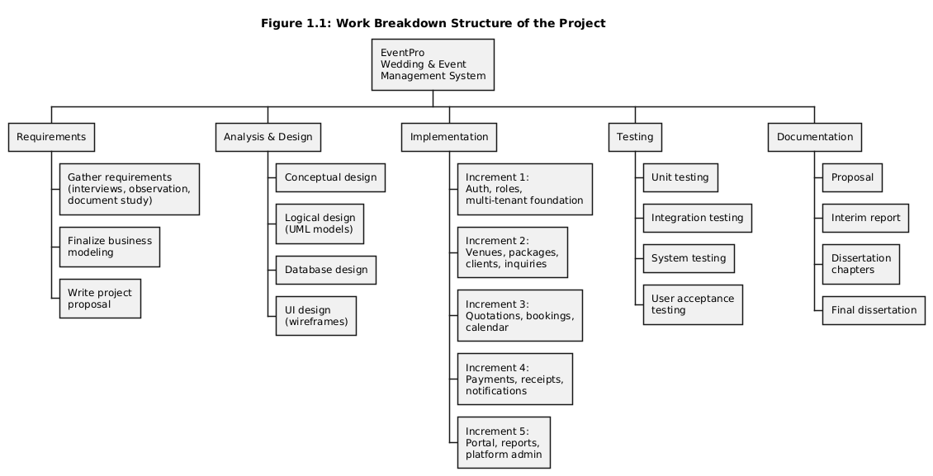
Figure 1.1: Work Breakdown Structure of the Project

1.5 Structure of the Dissertation
The remainder of this dissertation is organized as follows. Chapter 2 analyses the existing manual process, reviews similar commercial systems, evaluates alternative design strategies, and defines the functional, security, and non-functional requirements together with the justification of the chosen SDLC model and technology stack. Chapter 3 presents the system design: the architecture, the UML behavioural and structural models, the database design with data dictionaries for the core tables, the user interface design, and the traceability of design elements back to requirements. Chapter 4 describes the implementation: the development environment, the module structure, the implementation of each functional module, the coding standards followed, the reused components, and the version-control practice; the critical source code realizing each module is listed and explained in Appendix D. Chapter 5 presents the evaluation: the testing strategy, unit and integration test cases per module, system testing, automated regression testing, and user acceptance testing with its results. Chapter 6 concludes the dissertation with a critical assessment of the solution, the lessons learnt, and the planned future work. The appendices provide the system manual (A), the user manual (B), samples of the management reports (C), and the complete code listing with explanations (D).

Chapter 2 – Analysis

2.1 Analysis
System analysis is the phase in which the problem domain is studied in depth so that the requirements of the proposed solution can be established with confidence before any design work begins [1]. This chapter describes how requirements were gathered, analyses the existing manual system and its failure points, reviews similar systems to learn from existing approaches, evaluates alternative design strategies, and then states the functional, security, and non-functional requirements of the proposed system. It closes by justifying the chosen development methodology and technology stack.

2.1.1 Requirement Gathering Techniques
Interviews. Semi-structured interviews were conducted with the owner and two coordinators of an operating event business. The owner's interview focused on business goals, reporting needs, and pain points; the coordinators' interviews walked through their daily activities in detail — how an inquiry is handled, how a quotation is produced, how a booking is recorded, and how payments are collected. Follow-up interviews were held after each development increment to validate the implemented behaviour.
Observation of the working environment. Two half-day observation sessions were spent at the business's front office, watching real inquiries being handled and real bookings being made. Observation surfaced facts that interviews alone had missed — for example, that the venue diary is consulted by several people concurrently during peak season, which is precisely when double bookings occur, and that coordinators keep private side-notes about vendor commitments that no one else can see.
Document study. The documents used daily by the business — the venue diary, several past quotations, the payment spreadsheets, and vendor contact lists — were studied to extract the implicit data model of the business: what attributes a booking actually carries, how installments are named and scheduled, and what a quotation must contain to be acceptable to customers.
Review of similar systems. Finally, commercial systems addressing the same domain were reviewed (Section 2.1.3) both to identify expected baseline functionality and to find the gaps — local payments, white-labelling, multi-tenancy — that the proposed system should fill.

2.1.2 Existing System and Problem Description
In the existing manual process, a customer inquiry arrives by telephone, walk-in, or social media message. A coordinator writes the customer's name, contact number, expected guest count, and preferred date into a notebook, then checks the physical venue diary for that date. If the date appears free, the coordinator prepares a quotation by opening a previous customer's quotation in a word processor, editing the names, dates, and amounts, and emailing or printing it. There is no systematic record of which quotations were sent, to whom, or when they lapse.
If the customer accepts — often after several rounds of telephone negotiation that are nowhere recorded — the coordinator pencils the booking into the diary and collects an advance payment, recording it in a spreadsheet on their own computer. Subsequent installments are collected in the months before the event, each recorded in the same manner. In the final weeks, the coordinator telephones decorators, photographers, and caterers to confirm arrangements, keeping the commitments in personal notes. After the event, the balance is settled, and the file is closed. Management learns about the month's business through verbal updates and an occasional manually assembled summary.
The weaknesses of this process, confirmed by both interviews and observation, are significant. The venue diary is a single physical book: availability cannot be checked remotely, concurrent access during peak season causes conflicting entries, and a lost or damaged diary would be a business catastrophe. Quotations prepared by copy-editing old documents frequently contain stale prices and other customers' residual details. Sent quotations are not tracked, so follow-ups depend on individual memory and many leads silently expire. Payment records fragmented across personal spreadsheets cannot be consolidated reliably; outstanding balances are discovered late, and there is no audit trail of who recorded which payment. Vendor commitments living in private notes are invisible to colleagues, so staff absence disrupts event preparation. Management reporting requires hours of manual collation and is therefore rarely produced. Figure 2.1 illustrates the existing process as a flowchart, marking the points at which these failures occur.
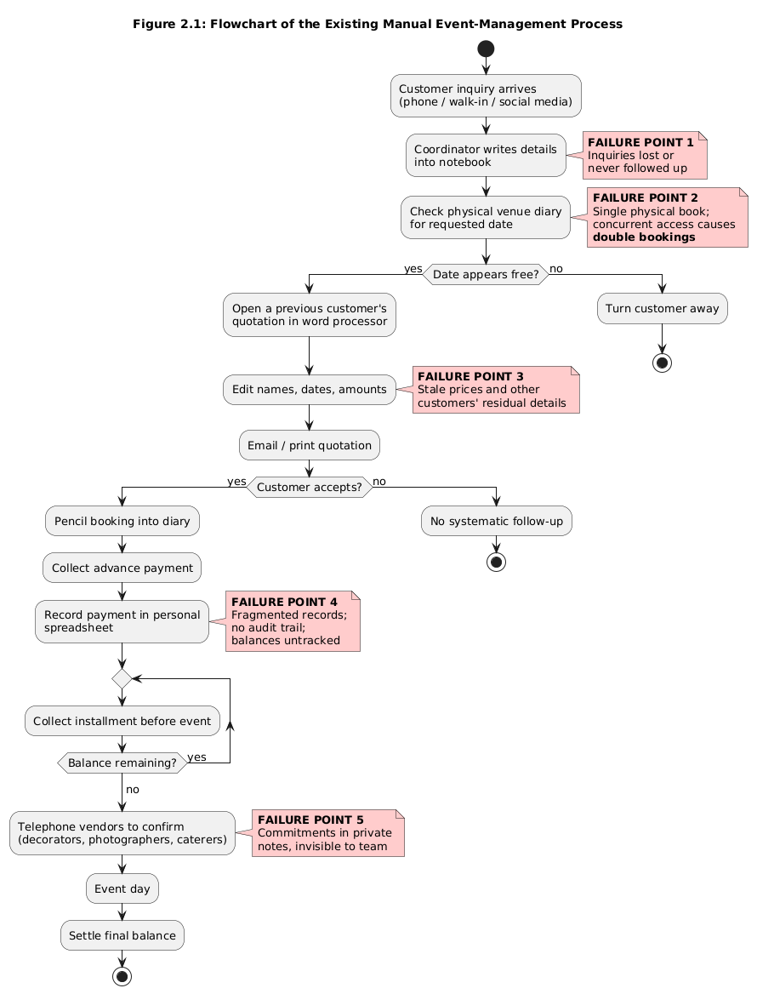
Figure 2.1: Flowchart of the Existing Manual Event-Management Process

2.1.3 Review of Similar Systems
Four representative systems were reviewed before designing the proposed solution, spanning the international SaaS products an event business might realistically consider.
Planning Pod. Planning Pod is a commercial cloud platform for event and venue management offering booking management, invoicing, floor-plan design, and client communication tools [2]. Its venue-booking calendar and invoicing are mature, and it prevents booking conflicts. However, it is priced per user in US dollars, offers no Sri Lankan payment-gateway integration, provides no white-labelling, and each subscribing business is an isolated account — there is no notion of a local operator hosting many businesses.
HoneyBook. HoneyBook targets independent event professionals and freelancers with inquiry capture, proposals, contracts, invoicing, and online payments [3]. Its client-flow automation (inquiry to proposal to contract to payment) is the best of the reviewed systems and influenced the inquiry-to-quotation flow of this project. However, HoneyBook is a single-business tool oriented to individuals: it has no multi-venue availability calendar, no vendor coordination, and its payments support only US/Canadian processors.
Event Temple. Event Temple is a hotel and venue management platform providing sales pipelines, booking calendars, e-proposals, and reporting [4]. It handles multi-venue chains well and its reporting is strong, but it is oriented toward hotel sales teams, is comparatively expensive, does not provide a customer self-service portal of the kind required here, and again offers no local payment support or white-labelling.
Tave. Tave is a studio-management system popular with photographers and small event vendors, offering lead capture, quotes, contracts, and scheduling [5]. Its questionnaire-driven lead forms are noteworthy, but it manages a service provider's diary rather than physical venues, and has no concept of venue availability, packages with per-guest pricing, or multi-company operation.
Table 2.1 compares the reviewed systems against the proposed system across the key capabilities identified during requirement gathering. The comparison makes the gap explicit: no reviewed system combines venue-centric booking, local online payments, a client portal, white-label branding, and multi-tenant operation — the combination this project delivers.
Feature | Planning Pod | HoneyBook | Event Temple | Tave | Proposed System
Inquiry capture and lead management | ✓ | ✓ | ✓ | ✓ | ✓
Multi-venue availability calendar | ✓ | ✗ | ✓ | ✗ | ✓
Quotation workflow with PDF export | ✓ | ✓ | ✓ | ✓ | ✓
Double-booking prevention | ✓ | ✗ | ✓ | ✗ | ✓
Guest-count-based package pricing | ✗ | ✗ | ✓ | ✗ | ✓
Installment payment tracking | ✓ | ✓ | ✗ | ✓ | ✓
Local payment gateway (PayHere) | ✗ | ✗ | ✗ | ✗ | ✓
Vendor assignment per booking | ✗ | ✗ | ✗ | ✗ | ✓
Staff task management | ✓ | ✗ | ✓ | ✗ | ✓
Client self-service portal | ✓ | ✓ | ✗ | ✓ | ✓
White-label branding per company | ✗ | ✗ | ✗ | ✗ | ✓
Multi-tenant (many companies, one deployment) | ✗ | ✗ | ✗ | ✗ | ✓
Audit log of user actions | ✗ | ✗ | ✓ | ✗ | ✓
Table 2.1: Similar Systems Comparison Matrix

2.1.4 Comparison of Alternative Design Strategies
Before committing to a bespoke web application, three alternative strategies were evaluated.
Continue with the manual system, improved with shared spreadsheets. Moving the diary and payment records to shared cloud spreadsheets would cost nothing and improve visibility, but it cannot enforce any rules: nothing prevents two coordinators from entering the same date, validates amounts, drives a quotation workflow, or gives customers self-service. The core failure modes would persist.
Adopt or customize an off-the-shelf product. Subscribing to one of the reviewed SaaS products would deliver working software immediately, but at recurring foreign-currency cost, without local payments, without white-labelling, and with no path to multi-tenant operation. Customizing an open-source booking system was also considered, but the surveyed candidates model rooms or appointments rather than events with packages, installments, and vendors; the customization effort approached that of a purpose-built system while inheriting a foreign codebase.
Develop a purpose-built web application. A bespoke web system can encode the exact workflow of the business, integrate PayHere, be branded freely, and be architected for multi-tenancy from the start. It is accessible from any location around the clock, requires no client-side installation, and is straightforward to deploy on inexpensive local hosting. This strategy was selected; the frameworks and packages chosen (Section 2.1.6.2) keep its development effort realistic for a single-developer academic project.

2.1.5 System Requirements Analysis
The requirements below were derived from the interviews, observations, document study, and the review of similar systems, and were validated with the client before design commenced. They are grouped by functional module.

2.1.5.1 Functional Requirements
FR1 — User and access management. The system shall support the roles super administrator, tenant owner, administrator, manager, staff, and client. Administrators shall create, edit, deactivate, and delete staff accounts; clients shall self-register through the public site. Every route and action shall be permitted only to the roles authorized for it, and users shall be able to manage their own profile and password.
FR2 — Venue and package management. The system shall allow each tenant to maintain multiple venues with name, capacity, base price, and weekend surcharge, and to build modular event packages with included services, base price, and per-guest pricing. Venues and packages shall be presentable on the tenant's public site.
FR3 — Inquiry management. The system shall capture inquiries from a public form (name, contact details, event type, preferred date, guest count, message, optional venue of interest), normalize each inquiry into a client record — creating the client if the e-mail is new, otherwise linking to the existing client — and allow staff to view, filter, respond to, and convert inquiries.
FR4 — Quotation management. The system shall generate quotations from an inquiry or from scratch, pricing the venue (with weekend surcharge), the package (per guest), additional services, surcharges, discounts, and tax into an itemized breakdown; assign sequential quotation numbers with a configurable prefix; apply a configurable validity period; enforce the status workflow draft → sent → accepted / rejected / expired; and export branded quotation PDFs.
FR5 — Booking management. The system shall create bookings only for available venue dates — a date is unavailable if any non-cancelled booking exists for that venue on that date — assign sequential booking numbers, maintain the statuses pending, tentative, confirmed, completed, and cancelled, record setup and event times and guest count, compute and maintain the balance, and present all bookings on list, detail, and unified calendar views. Editing a booking shall re-check availability while ignoring the booking itself.
FR6 — Payment management. The system shall record installment payments by cash, bank transfer, cheque, and card with named installments, dates, and reference numbers; accept online payments through the PayHere gateway in sandbox and live modes; verify every gateway callback cryptographically before recording it; recalculate the booking's paid and balance amounts transactionally on every payment; generate sequential payment numbers and PDF receipts; and notify staff when payments are received.
FR7 — Vendor and staff coordination. The system shall maintain a directory of external vendors with service categories and contacts, assign vendors to bookings with the agreed service and cost, and create, assign, and track event-preparation tasks for staff members with due dates and statuses.
FR8 — Client portal. Authenticated clients shall view their bookings with status and balance, their quotations, and their full payment history, and shall be able to pay outstanding installments online through PayHere.
FR9 — Reporting and notifications. The system shall produce a management dashboard (upcoming events, revenue, outstanding balances, booking-status distribution) and detailed revenue and booking reports with date-range filtering, top-venue analysis, and PDF export; and shall deliver in-app notifications and best-effort e-mails for significant events (new inquiry, payment received, upcoming installment due).
FR10 — Platform administration. The super administrator shall create, suspend, and activate tenant companies; define subscription plans; impersonate tenant users for support with the action audited; manage platform settings; and review a platform-wide audit log of critical actions.
FR11 — White-label customization. Each tenant shall configure its own logo, favicon, and accent colour, applied across its admin area, portal, PDFs, and public pages, and shall define custom fields on core entities to capture business-specific data without code changes.

2.1.5.2 Security as a Functional Requirement
Security is treated as a core functional requirement of this system rather than a quality attribute bolted on later, because the platform holds personal client data and financial records for multiple independent companies within one deployment; a single isolation defect would expose one company's business to another. The following security functions are therefore mandatory and were implemented and tested as features in their own right:
- Authentication and session management: password-based login with hashed credentials, session regeneration on login, and administrative visibility of active sessions.
- Role-based access control: permissions enforced by middleware on every route and re-checked in controllers for sensitive actions, so a user can never reach a function outside their role.
- Tenant data isolation: every tenant-owned record carries a tenant identifier, and a global query scope automatically restricts every query to the current tenant, making cross-company data leakage impossible at the application layer (Appendix D.1); validation rules for foreign keys are likewise tenant-scoped so one tenant cannot reference another tenant's records.
- Input validation and injection defence: exhaustive server-side validation on all forms; parameterized queries through the ORM against SQL injection; automatic output escaping in the template layer against XSS; and sanitization of tenant-supplied branding CSS.
- CSRF protection: framework CSRF tokens on all state-changing requests, with the payment-gateway webhook as the single, deliberately hardened exception.
- Payment callback verification: every PayHere server notification is verified by recomputing its MD5 signature with the tenant's secret and comparing in constant time, then cross-checking merchant, amount, and currency, with idempotent processing (Appendix D.10, D.11), so payment records cannot be forged or replayed.
- Audit logging: logins, impersonation, and create/update/delete actions on critical records are written to an activity log with the acting user, providing accountability across tenants.

2.1.5.3 Non-Functional Requirements
- Performance: common pages shall load within three seconds on a standard broadband connection; venue availability checks shall respond in under one second; and list screens shall remain responsive with several years of booking data through pagination and database indexing.
- Usability: the interface shall be clean and consistent so that a coordinator can create a booking after brief initial training; validation errors shall appear inline beside the offending field; and the UI shall be responsive on desktop, tablet, and mobile browsers.
- Reliability: payment recording and booking-balance recalculation shall run inside database transactions so records can never be left in an inconsistent state; gateway webhooks shall be idempotent so duplicate notifications cause no double-recording.
- Scalability: the multi-tenant design shall allow new companies to be added by configuration alone; the schema shall carry indexes on all high-traffic lookups (notably venue/date and tenant-scoped keys).
- Maintainability: the codebase shall follow the framework's conventions and the PSR-12 style, isolate business logic in service classes, and be covered by an automated test suite that can be run with a single command.
- Availability and portability: as a web application the system shall be reachable at any time from any location; it shall run identically on MySQL in production and SQLite in development.

2.1.6 Justification of Development Approach and Technologies

2.1.6.1 Chosen SDLC Model and Rationale
An iterative and incremental development model was selected for this project. The requirements, while well understood at a high level after the analysis activities above, were expected to be refined as the client saw working software — particularly around the quotation workflow, the calendar, and the layout of reports, which are matters of daily working habit rather than written specification. A pure waterfall approach would have locked in these details too early and concentrated all integration risk at the end of the project; a fully agile process, conversely, offers less of the documented, gated structure an individually assessed academic project requires. The iterative model provides the appropriate middle ground: each iteration has its own analysis refinement, design, implementation, and test activities, ends with a demonstrable increment, and feeds validated learning into the next iteration [1].
Five increments were planned and delivered: (1) project skeleton, authentication, roles, and the multi-tenant foundation; (2) venues, packages, clients, and inquiries; (3) quotations and bookings with availability checking and the calendar; (4) payments — manual and PayHere — receipts, and notifications; (5) the client portal, reports, platform administration, and white-label settings. Each increment concluded with a demonstration to the client and a regression run of the automated test suite, so defects were discovered while their causes were still fresh and the software never drifted from the client's expectations. This discipline directly reduced implementation defects and risk, as required by the project brief.

2.1.6.2 Technology Stack Justification
PHP 8.2 and Laravel 12. Laravel is a mature, extensively documented MVC framework that provides authentication, validation, an expressive ORM (Eloquent), database migrations, queued jobs, mail, and testing support out of the box [6]. Its ecosystem includes production-grade packages for precisely the cross-cutting needs of this project — roles and permissions, multi-tenancy, settings, activity logging, and media handling (the Spatie family) [7] — which allowed project effort to be concentrated on the domain logic rather than infrastructure. PHP hosting is inexpensive and ubiquitous in Sri Lanka, matching the budgets of the target businesses.
Vue 3 with Inertia.js. The administration area and portal are single-page applications built with Vue 3 [8] connected to Laravel through Inertia.js [9]. Inertia lets server-side controllers return Vue pages directly, providing the fluid, app-like experience needed for calendar- and form-heavy screens without building and securing a separate REST API layer — a substantial saving in both effort and attack surface for a single developer.
Tailwind CSS 3 and Vite 6. Tailwind's utility-first approach [10] enabled a consistent, responsive interface to be produced quickly and made per-tenant accent-colour theming straightforward; Vite provides fast asset building for development and optimized production bundles.
MySQL 8 / SQLite. A relational database is the natural fit for the strongly structured, transactional data of bookings and payments, where referential integrity and exact decimal arithmetic are essential. MySQL 8 is used in production; SQLite — a single, zero-configuration file — is used for development, automated testing, and demonstrations, with Eloquent making the two interchangeable.
Supporting tools. FullCalendar 6 renders the booking calendar; barryvdh/laravel-dompdf generates quotation, receipt, and report PDFs; maatwebsite/excel supports tabular exports; PHPUnit 11 drives automated testing; Laravel Pint enforces PSR-12 code style; Larastan provides static analysis; and Git with GitHub provides version control and defect tracking.

Chapter 3 – Design

3.1 Introduction to System Design
The design phase converts the requirements established in Chapter 2 into a structured, detailed plan for implementation. The goal of the design process is to produce a model of the system that can be used to build it with confidence: the architecture that hosts the functionality, the internal structure and behaviour of the components, the database that persists the business's data, and the interfaces through which users work. This chapter presents each of these in turn. Every design element is traceable to a requirement from Chapter 2, and Section 3.9 provides the explicit mapping.

3.2 Design Principles and Methodologies
The system follows an object-oriented design based on the Model-View-Controller (MVC) architectural pattern, extended with a dedicated service layer. The rationale for this combination is separation of concerns: controllers remain thin — they authorize, validate, delegate, and respond — while business rules that span entities live in single-responsibility service classes. AvailabilityService owns the availability rules; PricingService owns all price composition; QuotationService owns quotation creation and its PDF rendering; PaymentService is the single writer of payment records and booking balances; PayHereService owns gateway credentials, payload signing, and signature verification. Concentrating each rule in one class makes the rules independently testable and prevents the divergence that occurs when the same logic is re-implemented in several controllers.
Three further principles shape the design. Modularity: each functional module (venues, packages, inquiries, quotations, bookings, payments, clients, vendors, staff, tasks, reports, settings) has its own controller, model, policies, and Vue pages, so modules can be developed, tested, and modified independently. Reusability: cross-cutting behaviour is expressed once — tenant scoping as a model trait applied to every tenant-owned model, authorization as middleware and policies, layout as shared Vue components. Defence in depth: security checks are layered (middleware, controller re-checks, tenant-scoped validation rules, model-level scoping) so that no single omission produces a vulnerability. The Unified Modeling Language is used throughout this chapter to express the design [11].

3.3 System Architecture Overview
The system uses a layered client-server architecture, shown in Figure 3.1. The presentation layer consists of Vue 3 pages (the admin SPA and portal) and Blade templates (the public site) rendered in the user's browser. The application layer is the Laravel application: every request enters through the route definitions and passes through a middleware pipeline — authentication, tenant resolution (SetCurrentTenant), permission enforcement, and the tenant-active check (EnsureTenantActive) — before reaching a controller, which delegates to the service layer. The data layer comprises Eloquent models mapped to the relational database, with all tenant-owned models automatically scoped to the current tenant. External systems — the PayHere payment gateway and the SMTP mail service — are integrated at the service layer behind dedicated classes, so the rest of the application is insulated from their details.
Tenant resolution deserves particular note because it underpins the entire multi-tenant design. A tenant-finder inspects each request's host name: an exact custom-domain match selects that tenant; otherwise a subdomain of the platform's base domain is interpreted as the tenant's slug; and in single-tenant mode the sole active tenant is selected regardless of host (Appendix D.2). Once the current tenant is established, the model-layer scope of Appendix D.1 confines every subsequent query to that tenant's rows. Suspended tenants are rejected at the middleware layer before any business logic runs.
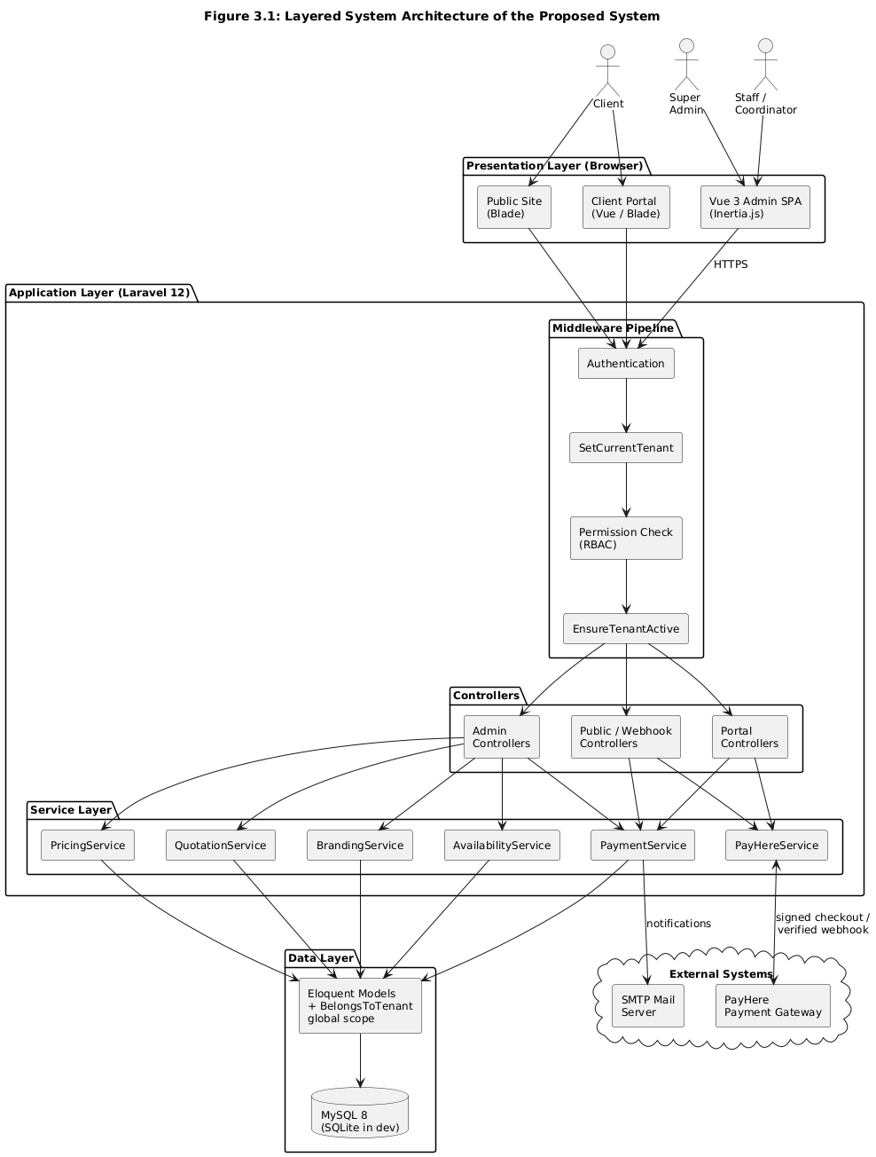
Figure 3.1: Layered System Architecture of the Proposed System

3.4 Use Case Model
The functional behaviour of the system is captured in the use case diagram of Figure 3.2. Four actors interact with the system. The Super Administrator manages tenants, subscription plans, platform settings, the platform audit log, and support impersonation. The Tenant Owner/Administrator manages the company's venues, packages, staff accounts, branding, custom fields, and payment settings, and can perform every managerial function. The Manager/Staff actor handles the daily workflow: viewing and responding to inquiries, building and sending quotations, creating and updating bookings, recording payments, assigning vendors, completing tasks, and generating reports (staff members hold a subset of these permissions). The Client submits inquiries from the public site, registers on the portal, views bookings, quotations, and payments, and pays installments online.
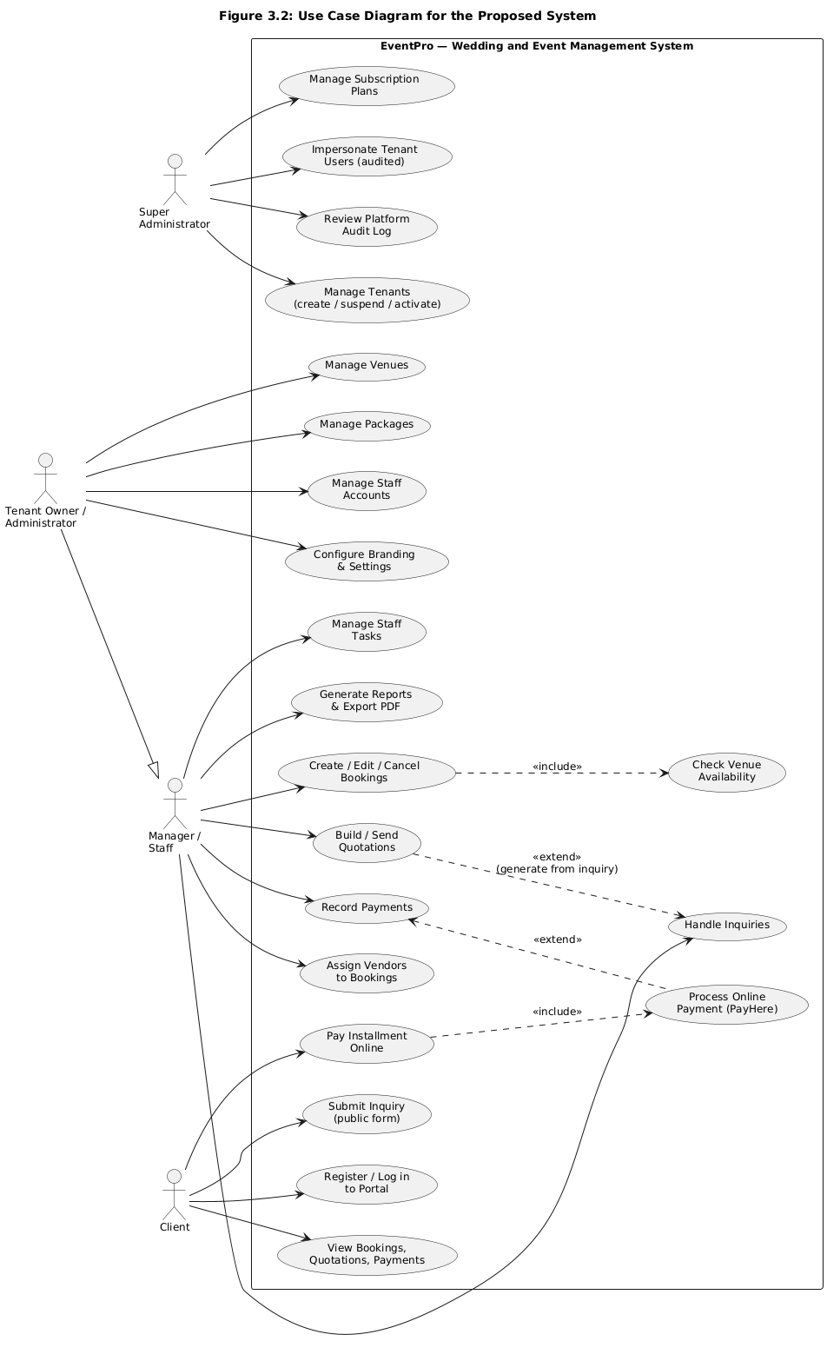
Figure 3.2: Use Case Diagram for the Proposed System
Table 3.1 documents the highest-value use case — Create Booking — in detail; the remaining use cases were documented at the same level of detail in the project's design workbook.
Item | Description
Use case name | Create Booking
Actors | Manager (primary); Administrator, Tenant Owner
Preconditions | Actor is authenticated with a role permitted to create bookings; the client and venue exist within the actor's tenant.
Main flow | 1. Actor opens the New Booking form. 2. Actor selects client, venue, and event date, and enters event type, times, guest count, and amounts. 3. System validates all inputs, including tenant-scoped existence of the client and venue and that the date is today or later. 4. System checks venue availability for the date. 5. System creates the booking with a generated booking number, computes the balance, records the creating user, and confirms.
Alternative flows | 4a. The venue already has a non-cancelled booking on the date: the system rejects the request with the message “This venue is already booked on the selected date” and re-presents the form with the entered values. 3a. Any validation failure: inline errors are shown beside the offending fields.
Postconditions | A booking exists in status tentative (or the selected status), visible in the list and calendar; the venue date is no longer available.
Related requirements | FR5 (booking management); FR1 (access control); security requirements of Section 2.1.5.2.
Table 3.1: Use Case Description — Create Booking

3.5 Class Design
The static structure of the system is shown in the class diagram of Figure 3.3. The central domain classes are Tenant, User, Plan, Client, Venue, Package, Inquiry, Quotation, Booking, Payment, Vendor, Staff, and Task. A Tenant owns all business data and is associated with a Plan. A Booking belongs to a Client, a Venue, and optionally a Package; it aggregates many Payments and many Tasks, and is associated with many Vendors through the booking–vendor association class, which carries the assigned service description and agreed cost. A Quotation links a Client, Venue, and Package with an itemized pricing breakdown, and an accepted Quotation can be converted into a Booking. All tenant-owned classes mix in the BelongsToTenant behaviour, and Users carry roles that drive the permission checks throughout the system.
The service classes appear alongside the domain classes in the diagram: AvailabilityService (availability rules), PricingService (price composition), QuotationService (quotation creation and PDF), PaymentService (payment recording and balance recalculation), PayHereService (gateway integration), and BrandingService (per-tenant theming). Their operations correspond directly to the requirement groups of Chapter 2, and their implementations are listed in Appendix D.
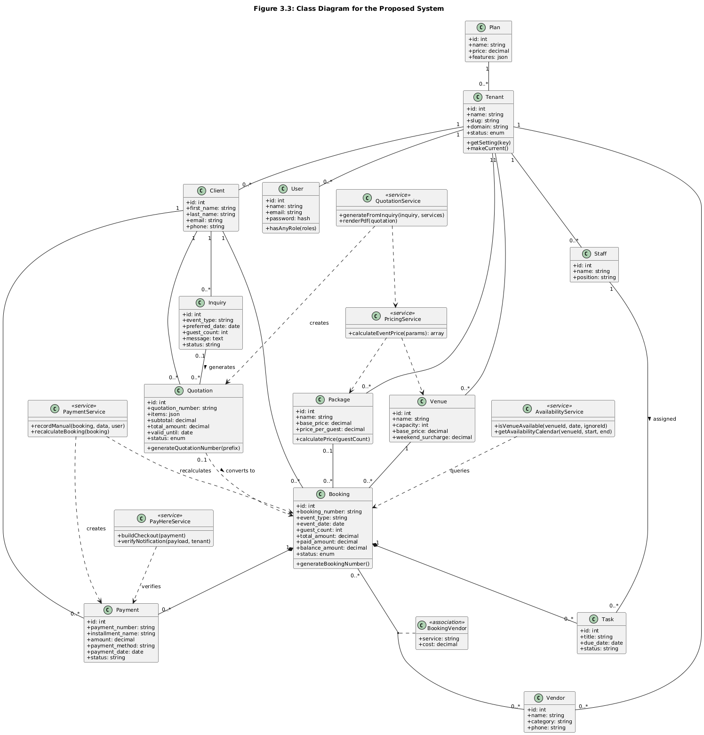
Figure 3.3: Class Diagram for the Proposed System

3.6 Data Modeling
The database design is expressed by the ER diagram in Figure 3.4 and realized through versioned migrations (a representative migration is listed in Appendix D.3). The schema is normalized to third normal form: clients, venues, packages, vendors, and staff exist independently and are referenced by bookings through foreign keys, eliminating redundancy, and the many-to-many relationship between bookings and vendors is resolved through the booking_vendor associative table. Referential integrity is enforced with foreign-key constraints chosen deliberately per relationship: deleting a tenant cascades to all its records; deleting a client cascades to that client's bookings; but deleting a package sets the booking's package reference to null, so historical bookings survive catalogue changes.
Business-level integrity is enforced in the schema as well. Booking numbers, quotation numbers, and payment numbers are unique per tenant through composite unique keys — two tenants may both have BK20260001, but no tenant can have it twice. A composite index on (venue_id, event_date) supports the constant-time availability lookups required by FR5, and further performance indexes cover the tenant-scoped foreign keys used by every list screen. Monetary values use exact decimal(14,2) columns to avoid floating-point error; status fields are constrained to enumerated values; and JSON columns hold the quotation's itemized breakdown and per-entity custom-field data, giving FR11 its flexibility without schema changes. Tables 3.2 to 3.4 provide the data dictionary for the three most important tables; the full dictionary for all tables was maintained in the design workbook.
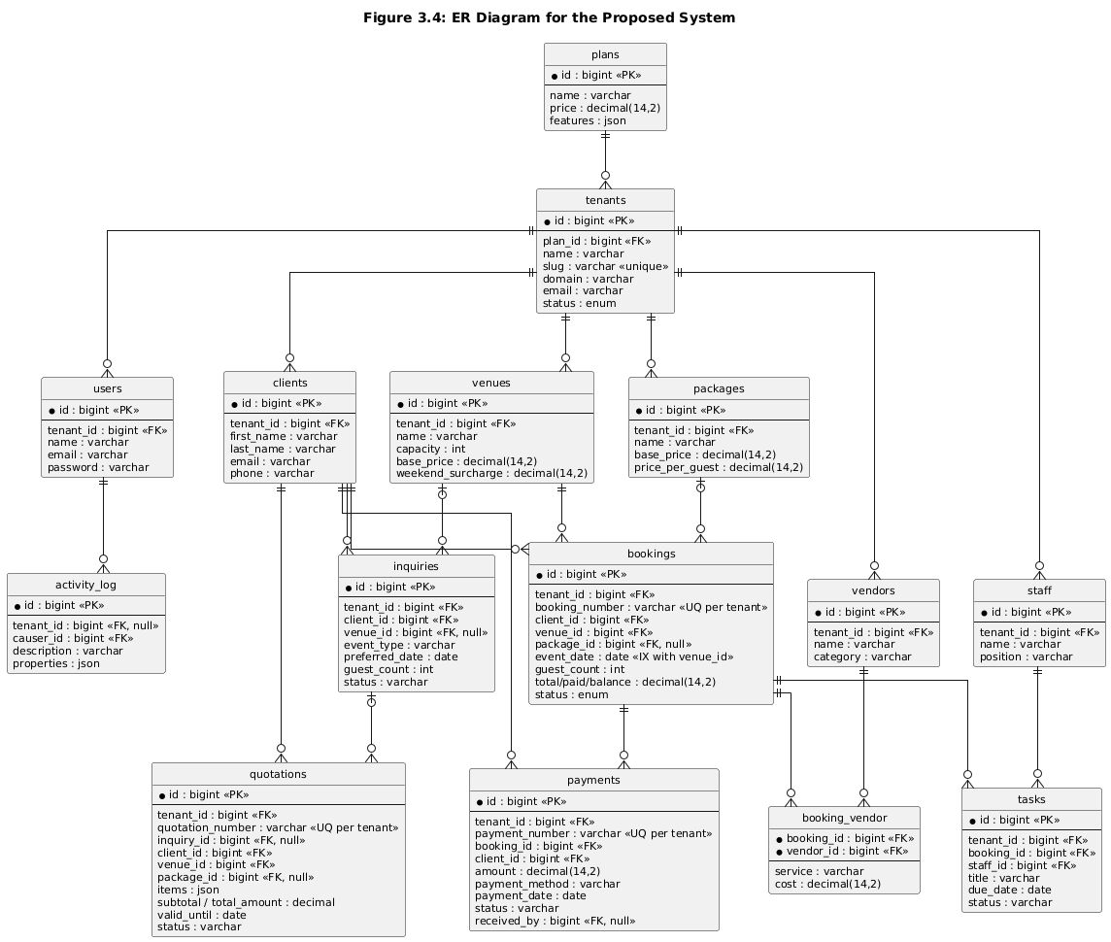
Figure 3.4: ER Diagram for the Proposed System
Column | Type | Description / Constraints
id | bigint, PK | Surrogate primary key.
tenant_id | bigint, FK | Owning tenant; cascade on delete; part of unique key with booking_number.
booking_number | varchar(50) | Sequential business identifier (e.g. BK20260001); unique per tenant.
client_id | bigint, FK | Client who owns the event; cascade on delete.
venue_id | bigint, FK | Venue of the event; indexed with event_date for availability checks.
package_id | bigint, FK, nullable | Selected package; set null on package deletion.
event_type | varchar(50) | Wedding, corporate, conference, etc.
event_date | date | Event date; the unit of availability.
setup_time / event_start_time / event_end_time | time, nullable | Operational times for the event day.
guest_count | unsigned int | Expected guests; drives per-guest pricing.
total_amount / paid_amount / balance_amount | decimal(14,2) | Financial totals; paid and balance are maintained exclusively by PaymentService.
status | enum | pending, tentative, confirmed, completed, cancelled.
custom_data | json, nullable | Values of tenant-defined custom fields (FR11).
created_by | bigint, FK | User who created the booking, for accountability.
Table 3.2: Data Dictionary — bookings Table
Column | Type | Description / Constraints
id | bigint, PK | Surrogate primary key.
tenant_id | bigint, FK | Owning tenant; part of unique key with payment_number.
payment_number | varchar(50) | Sequential receipt identifier; unique per tenant.
booking_id / client_id | bigint, FK | Booking and client the payment settles.
installment_name | varchar, nullable | e.g. Advance, Second Installment, Final Balance.
amount / currency | decimal(14,2) / char(3) | Paid amount and currency (default LKR).
payment_method | varchar | cash, bank_transfer, cheque, card, or payhere.
payment_date | date, nullable | Value date; null until an online payment completes.
gateway columns | varchar, nullable | PayHere order/payment identifiers and raw status for reconciliation.
status | varchar | pending, completed, failed, refunded; only completed payments count toward balances.
received_by | bigint, FK, nullable | Staff member who recorded a manual payment.
Table 3.3: Data Dictionary — payments Table
Column | Type | Description / Constraints
id | bigint, PK | Surrogate primary key.
tenant_id | bigint, FK | Owning tenant; part of unique key with quotation_number.
quotation_number | varchar(50) | Sequential identifier with configurable prefix (e.g. QT-2026-0001).
inquiry_id / client_id / venue_id / package_id | bigint, FK | Source inquiry and quoted client, venue, and package.
event_date / guest_count | date / unsigned int | Quoted event parameters.
items | json | Itemized breakdown (venue, package, services, surcharges) produced by PricingService.
subtotal / discount_amount / tax_amount / total_amount | decimal(14,2) | Computed totals of the quotation.
valid_until | date | Expiry per the configurable validity period.
status | varchar | draft, sent, accepted, rejected, expired — the FR4 workflow.
prepared_by | bigint, FK | User who prepared the quotation.
Table 3.4: Data Dictionary — quotations Table

3.7 Workflow and Behavioral Modeling
Figure 3.5 models the booking-creation interaction as a sequence diagram, realizing the use case of Table 3.1. The coordinator submits the booking form; the controller authorizes the actor and validates the input with tenant-scoped rules; the AvailabilityService is asked whether the venue is free on the requested date; if a non-cancelled booking already exists the request is rejected with an inline error, otherwise the Booking is created with a generated booking number and the computed balance, and the user is redirected to the booking list. The corresponding source code is listed in Appendix D.5 and D.8.
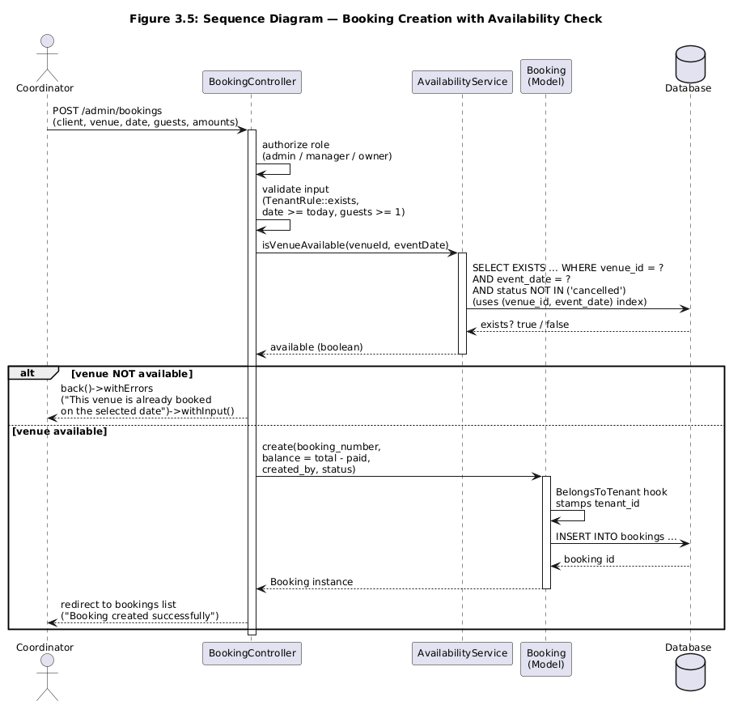
Figure 3.5: Sequence Diagram — Booking Creation with Availability Check
Figure 3.6 models the online payment flow, which involves an external system and is therefore the most intricate behaviour in the system. The client initiates payment from the portal; the application creates a pending Payment and builds a signed PayHere checkout payload; the client completes payment on PayHere's hosted page; PayHere then calls the application's public webhook server-to-server. The webhook handler locates the payment across tenants, derives the owning tenant, verifies the MD5 signature in constant time, cross-checks merchant, amount, and currency, applies idempotency (an already-completed payment is a no-op), and only then marks the payment completed and recalculates the booking balance through the same PaymentService path used by manual payments. The webhook is deliberately the single source of truth for online payment state; the client's return redirect merely displays status. The code is listed in Appendix D.10 and D.11.
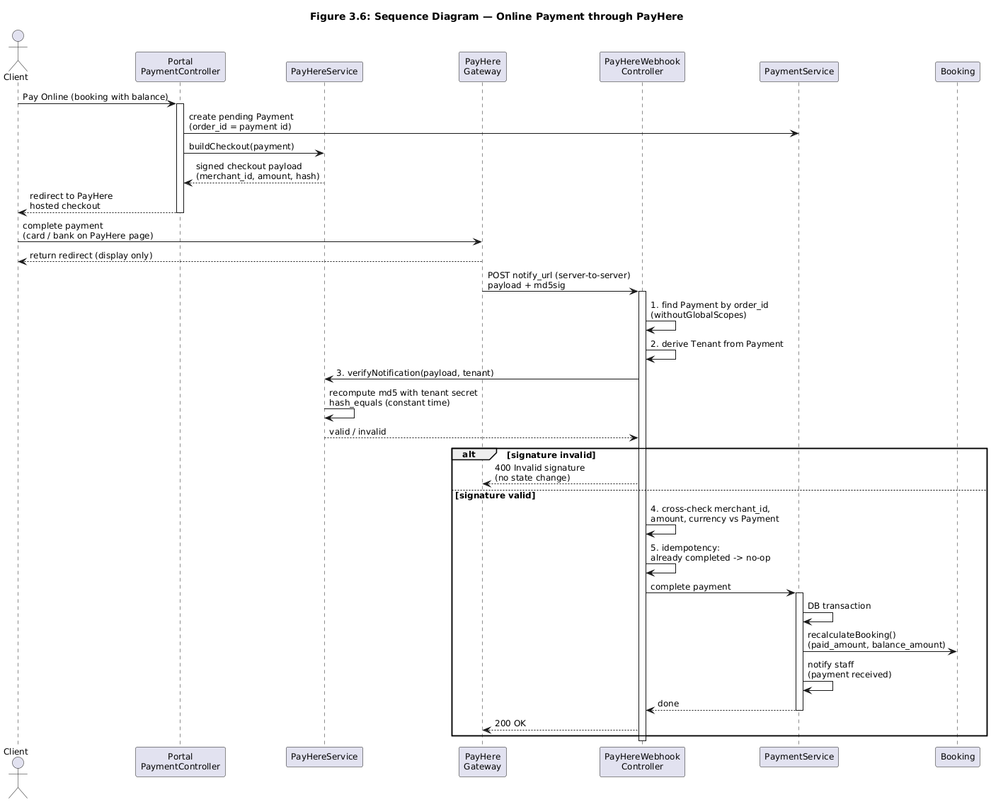
Figure 3.6: Sequence Diagram — Online Payment through PayHere
Figure 3.7 summarizes the overall business workflow as an activity diagram spanning the whole system: inquiry capture, client normalization, quotation preparation and the accept/reject/expire decision, booking creation with the availability gate, the installment collection loop with its manual/online branch, task and vendor coordination, event completion, and final settlement.
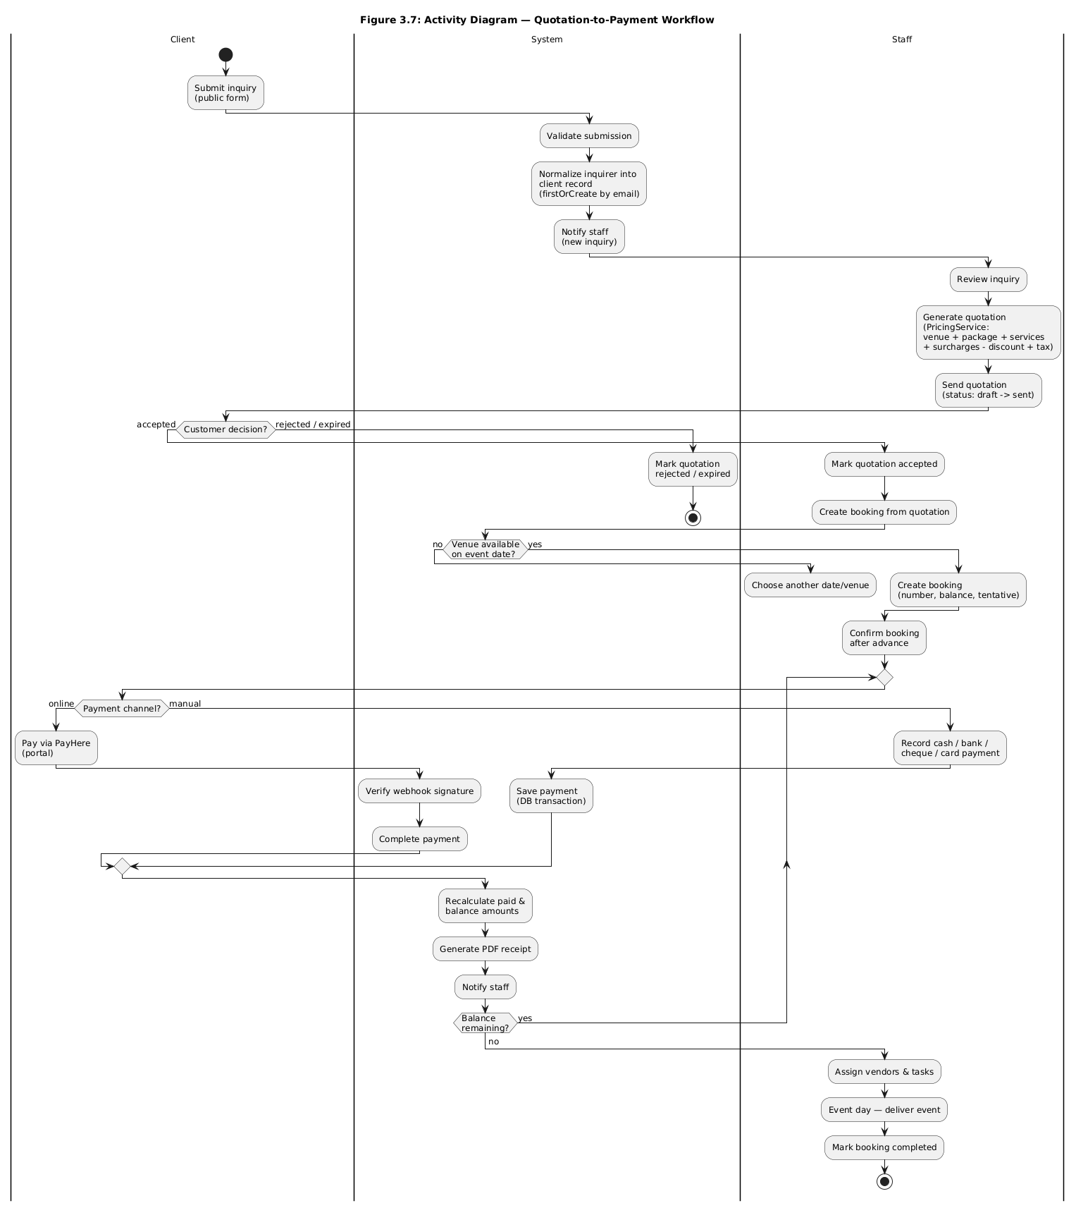
Figure 3.7: Activity Diagram — Quotation-to-Payment Workflow

3.8 User Interface Design
The user interface was designed around six principles. Clarity: each screen has one purpose stated in its heading, and the primary action is always the visually dominant control. Consistency: every list screen follows the same pattern (search, filters, table, row actions) and every form uses the same field components with inline validation, so skills learned on one screen transfer to all others. Efficiency: the workflows used many times daily — booking creation and payment recording — are reachable in two clicks from the dashboard, and forms provide immediate feedback such as the venue-availability warning before submission. Forgiveness: destructive actions (cancelling a booking, deleting a record) require explicit confirmation, and validation preserves the user's input on error. Common format: colour is used sparingly and meaningfully, with a single status palette (tentative, confirmed, completed, cancelled) applied identically across bookings, quotations, payments, and the calendar. Responsiveness: Tailwind's responsive utilities collapse the navigation and reflow tables on small screens, satisfying the usability NFR.
Per-tenant branding (logo, favicon, and accent colour) is applied by the BrandingService and theme engine without altering layout, so every tenant's users receive an interface that looks like their company's own product — the essence of the white-label requirement FR11. Figures 3.8 to 3.10 present wireframes of the three most important screens: the tenant dashboard, the booking creation form, and the client portal home page.
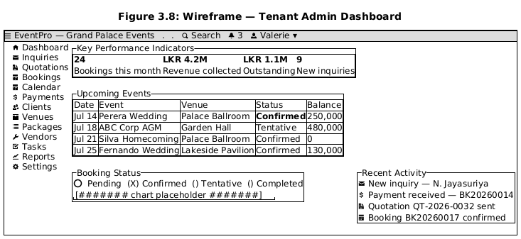
Figure 3.8: Wireframe — Tenant Admin Dashboard
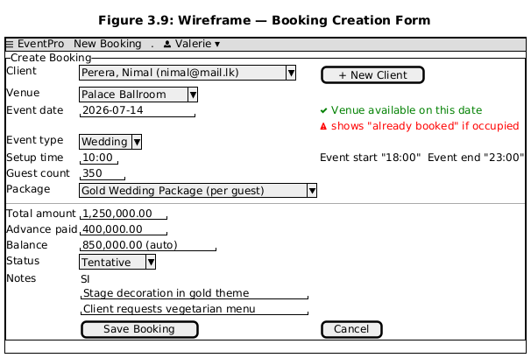
Figure 3.9: Wireframe — Booking Creation Form
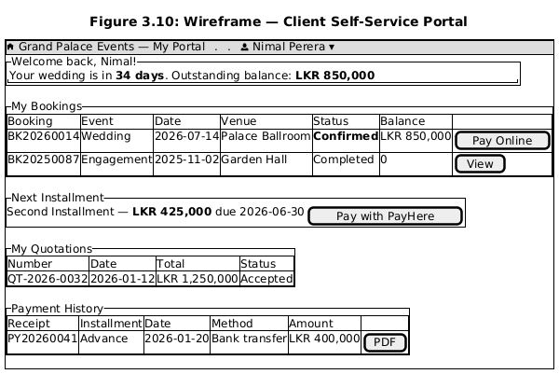
Figure 3.10: Wireframe — Client Self-Service Portal

3.9 Mapping of Requirements to Design Elements
Table 3.5 traces each requirement group from Chapter 2 to the design elements that realize it and to the appendix section where the corresponding code is listed, demonstrating that the design comprehensively addresses the analysed needs and providing end-to-end traceability from requirement through design to implementation.
Requirement | Realizing Design Elements | Code Listing
FR1 | User model, Spatie roles/permissions, auth + permission middleware, policies | Appendix D.8 (authorization in controller)
FR2 | Venue, Package classes and controllers; pricing attributes | Appendix D.6 (pricing)
FR3 | Inquiry class; public inquiry form; client normalization on capture | Appendix D.12
FR4 | Quotation class with status workflow; QuotationService; PricingService; PDF view | Appendix D.6, D.7
FR5 | Booking class; AvailabilityService; (venue_id, event_date) index; sequence of Figure 3.5 | Appendix D.3, D.4, D.5, D.8
FR6 | Payment class; PaymentService (single writer of balances); PayHereService; webhook; receipt PDF | Appendix D.9, D.10, D.11
FR7 | Vendor, Staff, Task classes; booking_vendor association | — (schema in Figure 3.4)
FR8 | Portal controllers and pages scoped to the authenticated client; online payment flow of Figure 3.6 | Appendix D.10, D.11
FR9 | Dashboard and Report controllers with aggregate queries; notification classes; mailables | —
FR10 | Tenant, Plan classes; platform controllers; impersonation; activity log | Appendix D.2
FR11 | BrandingService; theme engine; custom-field tables and service | —
Security (2.1.5.2) | BelongsToTenant global scope; middleware pipeline; tenant-scoped validation; signature verification; audit log | Appendix D.1, D.2, D.10, D.11, D.13
Table 3.5: Mapping of Requirements to Design Elements

Chapter 4 – Implementation

4.1 Development and Deployment Environment
The system was developed on the hardware and software environment summarized in Tables 4.1 and 4.2. For deployment, the application runs on any web server supporting PHP 8.2 (Apache or Nginx) with MySQL 8; for development, automated testing, and demonstrations, the built-in Laravel development server with a single-file SQLite database provides a zero-configuration environment that behaves identically at the application layer. Installation and execution details are given in Appendix A.
Component | Specification
Processor | Intel Core i5 (or equivalent), 2.0 GHz or higher
Memory | 8 GB RAM
Storage | 256 GB SSD
Display / Peripherals | Standard monitor, keyboard, and mouse
Table 4.1: Hardware Environment
Category | Software / Tool
Operating system | Windows 11 / Ubuntu 22.04 LTS
Language and framework | PHP 8.2, Laravel 12
Front end | Vue 3, Inertia.js 2, Tailwind CSS 3, Vite 6, FullCalendar 6
Database | MySQL 8 (production), SQLite (development, testing, demo)
Key packages | Laravel Sanctum; Spatie permission, multitenancy, settings, activitylog, medialibrary, translatable; barryvdh/laravel-dompdf; maatwebsite/excel; intervention/image
IDE and utilities | Visual Studio Code, Composer 2, Node.js 18 / NPM, Postman
Quality tools | PHPUnit 11, Laravel Pint (PSR-12), Larastan (static analysis)
Version control | Git with GitHub
Table 4.2: Software and Tools Used

4.2 Module Structure
The implementation follows the standard Laravel application layout, organized so that each functional module is independently locatable and modifiable. Controllers are grouped by audience: app/Http/Controllers/Admin contains the administration modules (dashboard, bookings, calendar, payments, quotations, inquiries, venues, hotels, packages, clients, vendors, staff, tasks, reports, notifications, users, tenants, plans, platform settings, audit log, impersonation, themes, custom fields, and settings), app/Http/Controllers/Portal contains the client-facing portal and its payment controller, and the root controller namespace holds the public-site controllers (inquiries, venues, packages) and the PayHere webhook. All business logic resides in app/Services; shared model behaviour in app/Models/Concerns; multi-tenancy plumbing in app/Multitenancy and app/Http/Middleware; authorization policies in app/Policies; and mail and notification classes in app/Mail and app/Notifications. The Vue pages mirror the controller structure under resources/js/Pages, and the database schema lives entirely in versioned migrations under database/migrations. Figure 4.1 shows the resulting structure.
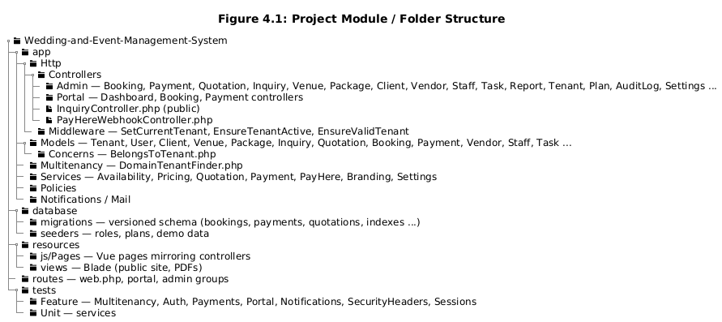
Figure 4.1: Project Module / Folder Structure

4.3 Implementation of the Core Modules
This section explains how each functional module was implemented, referencing the code listings in Appendix D where the critical source is reproduced in full and annotated. Collectively these modules realize every functional requirement of Chapter 2 through the design of Chapter 3.

4.3.1 Multi-Tenant Foundation
The foundation of the entire system is the pair of mechanisms that establish and enforce the current tenant. Tenant resolution is performed per request by the DomainTenantFinder (Appendix D.2), which matches the request host against custom domains, then platform subdomains (interpreting the subdomain as the tenant's slug), and finally falls back to the sole active tenant in single-tenant mode; suspended tenants are never resolved. Tenant enforcement is performed by the BelongsToTenant trait (Appendix D.1), mixed into every tenant-owned model: a global query scope appends the tenant condition to every query, and a creating hook stamps the tenant identifier on every new record. Because both mechanisms operate below the controllers, no feature code can forget them — the isolation property is structural rather than conventional, and it is verified continuously by the automated test of Appendix D.13.

4.3.2 Venue, Package, and Client Management
Venues, packages, and clients are conventional CRUD modules built on the shared list/form patterns of Section 3.8. Venues carry capacity, base price, and weekend surcharge; packages carry base and per-guest pricing with their included services; clients hold contact details and provide the 360-degree view that aggregates a client's inquiries, quotations, bookings, and payments on one profile page. All three modules inherit tenant scoping from the foundation and expose their catalogue data to the public site.

4.3.3 Inquiry Capture and Normalization
The public inquiry form posts to the inquiry controller listed in Appendix D.12. The controller validates the submission, resolves the receiving tenant, and then normalizes the inquirer into the client table: an existing client (matched by e-mail within the tenant) is reused, otherwise a client record is created from the submitted name and contact details, and the inquiry is linked to it. This normalization, done at the moment of capture, is what later allows a quotation and booking to be produced for the inquirer without re-entering their details, and gives the business a deduplicated client base from day one. Staff receive an in-app notification for each new inquiry.

4.3.4 Quotation Engine
Quotation generation composes two services. PricingService (Appendix D.6) computes the full price breakdown — venue price with weekend surcharge, package price scaled by guest count, additional services, surcharges, discount, and tax — in a single pass, returning an itemized structure. QuotationService (Appendix D.7) then persists the quotation: it prices the inquiry's parameters, applies the tenant's configurable number prefix and validity period, stores the itemized breakdown as JSON, and sets the initial draft status. The status workflow of FR4 is enforced in the service and controller layer so that, for example, only a sent quotation can be accepted and only a draft can be edited. Branded PDF rendering uses dompdf with the tenant's logo and accent colour supplied by the BrandingService.

4.3.5 Booking Lifecycle and Availability
The booking module is the heart of the system. Its store action (Appendix D.8) demonstrates the layered controls of the design: role authorization, exhaustive validation with tenant-scoped existence rules (TenantRule::exists ensures the referenced client, venue, and package belong to the current tenant), a past-date guard, and the availability gate provided by AvailabilityService (Appendix D.5) — a venue is available only if no non-cancelled booking exists for the date, an O(1) lookup thanks to the composite index. Booking numbers are generated sequentially per year (Appendix D.4), the balance is computed at creation, and the creating user is recorded. Editing re-runs the same availability check while ignoring the booking itself; cancellation frees the date. The unified calendar renders all bookings through FullCalendar, colour-coded by the shared status palette.

4.3.6 Payment Processing
All payment recording funnels through PaymentService, the single writer of booking paid/balance totals. Manual payments (Appendix D.9) are created inside a database transaction together with the booking recalculation, so a failure at any point leaves both untouched — the reliability NFR realized in code. Online payments use PayHere's hosted checkout: PayHereService resolves per-tenant credentials, builds the signed checkout payload, and — critically — verifies every inbound webhook by recomputing the MD5 signature and comparing in constant time (Appendix D.10). The webhook controller (Appendix D.11) applies its checks strictly in order: locate the payment, derive the tenant, verify the signature, cross-check merchant/amount/currency, apply idempotency, and only then complete the payment through the same recalculation path as manual payments. Receipts are generated as branded PDFs, and staff are notified of every payment received.

4.3.7 Vendors, Staff, and Tasks
The vendor directory stores external suppliers by category with their contacts; assignment to a booking creates a row in the booking_vendor association carrying the agreed service and cost, so the full supplier picture of an event — previously hidden in coordinators' private notes — is visible to the whole team. The task module lets managers create event-preparation tasks with assignees and due dates, tracked to completion on the booking's detail page.

4.3.8 Client Portal
The portal presents the authenticated client's bookings, quotations, and payment history, scoped by the client relationship on top of the tenant scope. Its most important function is online settlement: the portal payment controller creates a pending payment and hands the client to PayHere's hosted page, with the webhook of Section 4.3.6 completing the record. The portal shares the tenant's branding, so from the customer's perspective it is the event company's own product.

4.3.9 Reporting, Notifications, and Platform Administration
The dashboard aggregates KPIs (bookings, revenue, outstanding balances, inquiry counts) and the reports module computes revenue by month, booking-status distribution, and top venues by revenue over a selectable date range, with PDF export for management circulation. Notifications are delivered on the in-app bell with best-effort e-mail. Platform administration implements FR10: tenant CRUD with suspend/activate, subscription plans, audited support impersonation, platform settings, and the cross-tenant audit log built on the activity-log package.

4.4 Development Practices and Coding Standards
Consistent standards were maintained throughout the implementation. The code adheres to the PSR-12 style, enforced automatically by Laravel Pint on every commit; classes, methods, and database identifiers follow the framework's naming conventions; and every non-trivial class and method carries a doc-block describing its single responsibility — the doc-blocks visible in Appendix D are representative. Larastan static analysis was run regularly to catch type errors before runtime. Form requests and validation rules keep all input checking server-side regardless of any client-side conveniences. Reused components were factored deliberately: the shared Vue layout, navigation, form-field, and table components are written once and used by every module; the BelongsToTenant trait and TenantRule validation rules are the single implementations of tenant scoping; and the PDF layouts share one branded base template across quotations, receipts, and reports.

4.5 Software Version Management
Git was used for source control throughout the project, hosted on GitHub. Work proceeded on short-lived feature branches merged into the main branch after self-review, with descriptive commit messages recording the intent of each change; GitHub issues tracked defects found during testing. Database schema evolution was managed entirely through Laravel migrations, so every schema change is versioned alongside the code and reproducible on any environment — the incremental migrations visible in the repository (adding gateway columns to payments, adding performance indexes, extending tenants for demonstrations) document how the schema matured across the five increments. Figure 4.2 shows the repository and its history.
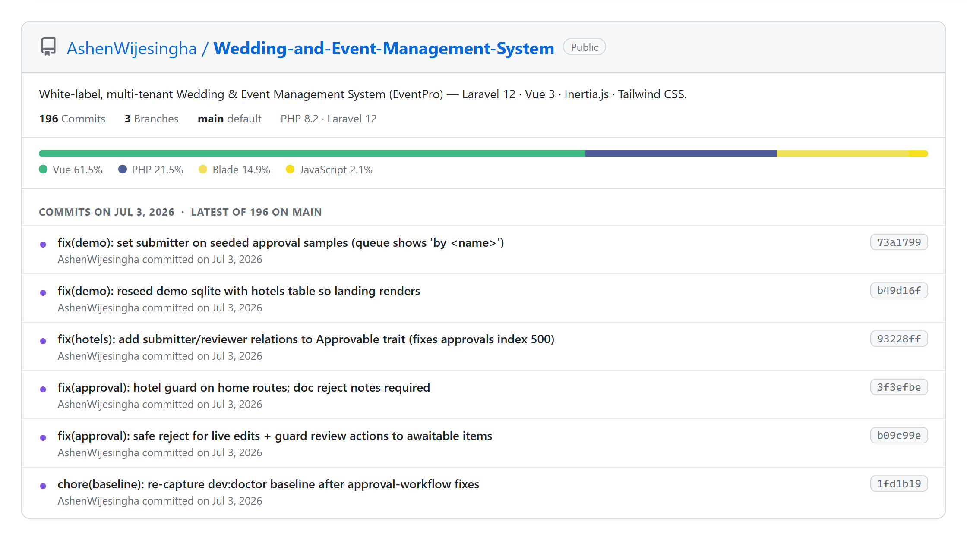
Figure 4.2: GitHub Repository and Commit History
Throughout the implementation, each completed module was checked against the design of Chapter 3 and the requirements of Chapter 2 — the traceability table (Table 3.5) served as the checklist — ensuring that the translation from plan to working code was complete before each increment was demonstrated.

Chapter 5 – Evaluation

5.1 Testing Strategy
The system was verified and validated at four levels, chosen so that each level catches the class of defect it is best suited to. Unit testing exercised individual service methods — availability logic, price composition, number generation, signature verification — in isolation using PHPUnit, with model factories providing controlled test data and an in-memory SQLite database giving fast, repeatable runs. Integration (feature) testing exercised complete request cycles — route, middleware pipeline, controller, service, and database — asserting on HTTP responses and resulting database state; the project's automated suite includes dedicated feature tests for multitenancy isolation (Appendix D.13), authentication, payments and the PayHere webhook, the client portal, notifications, approval gating, security headers, session management, and the demonstration seeders. System testing evaluated the assembled application end-to-end against realistic scenarios on seeded demonstration data. Finally, User Acceptance Testing placed the system before representative users of every role to confirm fitness for purpose.
Both white-box and black-box techniques informed the test design. White-box analysis of the service classes guided the unit tests toward branch coverage of the business rules (for example, the cancelled-booking branch and the ignore-self branch of the availability check). Black-box techniques — equivalence partitioning and boundary-value analysis on form inputs — generated the feature and system test cases, such as guest counts of 0 and 1, event dates of yesterday, today, and tomorrow, and payment amounts at and beyond the outstanding balance.

5.2 Unit and Integration Test Cases
Representative test cases and their outcomes are documented in Tables 5.1 to 5.6, organized by module. Each case states its input conditions and expected result; actual results were compared after execution, failures were fixed and re-run, and all listed cases passed in the final build.
Test ID | Test Case | Expected Result | Status
LM 1 | Log in with incorrect username and incorrect password | Login rejected with an error message | Passed
LM 2 | Log in with correct username and incorrect password | Login rejected with an error message | Passed
LM 3 | Log in with correct credentials | User authenticated and redirected to the role-appropriate dashboard | Passed
LM 4 | Submit the login form with empty fields | Validation messages shown; no authentication attempt | Passed
LM 5 | Staff user opens a URL restricted to administrators | HTTP 403 Forbidden response | Passed
LM 6 | User of Tenant A requests a booking record of Tenant B by its ID | Record not found (tenant scope hides it) | Passed
LM 7 | User of a suspended tenant attempts to use the admin area | Access blocked by the tenant-active check | Passed
LM 8 | Client attempts to open an admin route | Access denied; redirected to the portal | Passed
Table 5.1: Test Cases for the Login and Access-Control Module
Test ID | Test Case | Expected Result | Status
VP 1 | Create a venue with valid name, capacity, and base price | Venue saved and listed | Passed
VP 2 | Create a venue with a negative base price | Validation error; no record created | Passed
VP 3 | Create a package with per-guest pricing and included services | Package saved; price preview correct for a sample guest count | Passed
VP 4 | Price a weekend event at a venue with a weekend surcharge | Computed venue price includes the surcharge | Passed
VP 5 | Tenant A lists venues while Tenant B has venues too | Only Tenant A's venues are returned | Passed
Table 5.2: Test Cases for the Venue and Package Module
Test ID | Test Case | Expected Result | Status
IQ 1 | Submit the public inquiry form with valid details and a new e-mail | Inquiry saved; new client created and linked; staff notified | Passed
IQ 2 | Submit an inquiry with an e-mail belonging to an existing client | Inquiry linked to the existing client; no duplicate client | Passed
IQ 3 | Submit the inquiry form with an invalid e-mail address | Validation error shown on the form | Passed
QT 1 | Generate a quotation from an inquiry with venue, package, and services | Quotation created in draft with correct itemized totals and validity date | Passed
QT 2 | Send a draft quotation, then accept it | Statuses transition draft → sent → accepted | Passed
QT 3 | Attempt to accept a quotation still in draft | Transition rejected; status unchanged | Passed
QT 4 | Export a quotation to PDF | Branded PDF produced with the itemized breakdown | Passed
Table 5.3: Test Cases for the Inquiry and Quotation Module
Test ID | Test Case | Expected Result | Status
BM 1 | Create a booking for an available venue and date with valid data | Booking created with generated number and correct balance | Passed
BM 2 | Create a booking for a date on which the venue already has a non-cancelled booking | Rejected with “venue already booked on the selected date” | Passed
BM 3 | Create a booking with a past event date | Validation error: date must be today or later | Passed
BM 4 | Create a booking with guest count of zero | Validation error: guest count must be at least 1 | Passed
BM 5 | Create a booking on a date whose only existing booking is cancelled | Booking created successfully | Passed
BM 6 | Edit a booking keeping its own date | Availability check ignores the booking itself; update succeeds | Passed
BM 7 | Reference another tenant's client in the booking form | Validation error from the tenant-scoped existence rule | Passed
BM 8 | Cancel a confirmed booking | Status changes to cancelled; the date becomes available again | Passed
Table 5.4: Test Cases for the Booking Module
Test ID | Test Case | Expected Result | Status
PM 1 | Record a cash installment smaller than the outstanding balance | Payment saved; paid amount increases; balance decreases correctly | Passed
PM 2 | Record a payment settling the full balance | Balance becomes zero; receipt PDF can be generated | Passed
PM 3 | Record a payment with a negative amount | Validation error; no record created | Passed
PM 4 | Simulate a successful PayHere webhook with a valid signature | Payment marked completed; booking totals recalculated | Passed
PM 5 | Simulate a PayHere webhook with an invalid signature | Callback rejected with HTTP 400; no payment recorded | Passed
PM 6 | Replay a PayHere webhook for an already-completed payment | No-op (idempotent); totals unchanged | Passed
PM 7 | Simulate a webhook whose amount does not match the payment | Rejected as a field mismatch; no state change | Passed
PM 8 | Force a failure during payment saving (transaction test) | Neither the payment nor the booking totals are changed | Passed
Table 5.5: Test Cases for the Payment Module
Test ID | Test Case | Expected Result | Status
CP 1 | Client registers on the portal and logs in | Account created; portal dashboard shown with the client's data only | Passed
CP 2 | Client views bookings and payment history | Only that client's records are visible | Passed
CP 3 | Client with an outstanding balance initiates an online payment | Pending payment created; redirected to PayHere sandbox checkout | Passed
CP 4 | Client attempts to view another client's booking by URL manipulation | Access denied / not found | Passed
CP 5 | Fully paid booking is displayed in the portal | No payment button is offered | Passed
Table 5.6: Test Cases for the Client Portal

5.3 System Testing
After the modules were integrated, full end-to-end scenarios were executed on seeded demonstration data reflecting a realistic event business with multiple venues, packages, clients, and months of bookings. The principal scenario followed one event through its entire life: a public inquiry was submitted and automatically normalized to a client; a quotation was built from the inquiry, sent, exported to PDF, and accepted; a booking was created from the accepted quotation with the availability gate active; installments were collected both manually and through the PayHere sandbox, with receipts generated; vendors and staff tasks were assigned and completed; the event was marked completed; and the revenue reports were generated and exported, correctly reflecting every payment recorded. Parallel scenarios exercised the platform level: a second tenant was created, its data confirmed invisible to the first, a tenant was suspended and its users locked out, and a support impersonation was performed and found in the audit log.
Defects found during system testing — among them an incorrect balance display after editing a booking's total amount, a portal payment button appearing for fully paid bookings, and a calendar colour inconsistency for tentative bookings — were logged as GitHub issues, fixed, and re-tested. The automated regression suite was run after every fix to confirm no previously passing behaviour was broken; the output of a full run of the final build is shown in Figure 5.1.
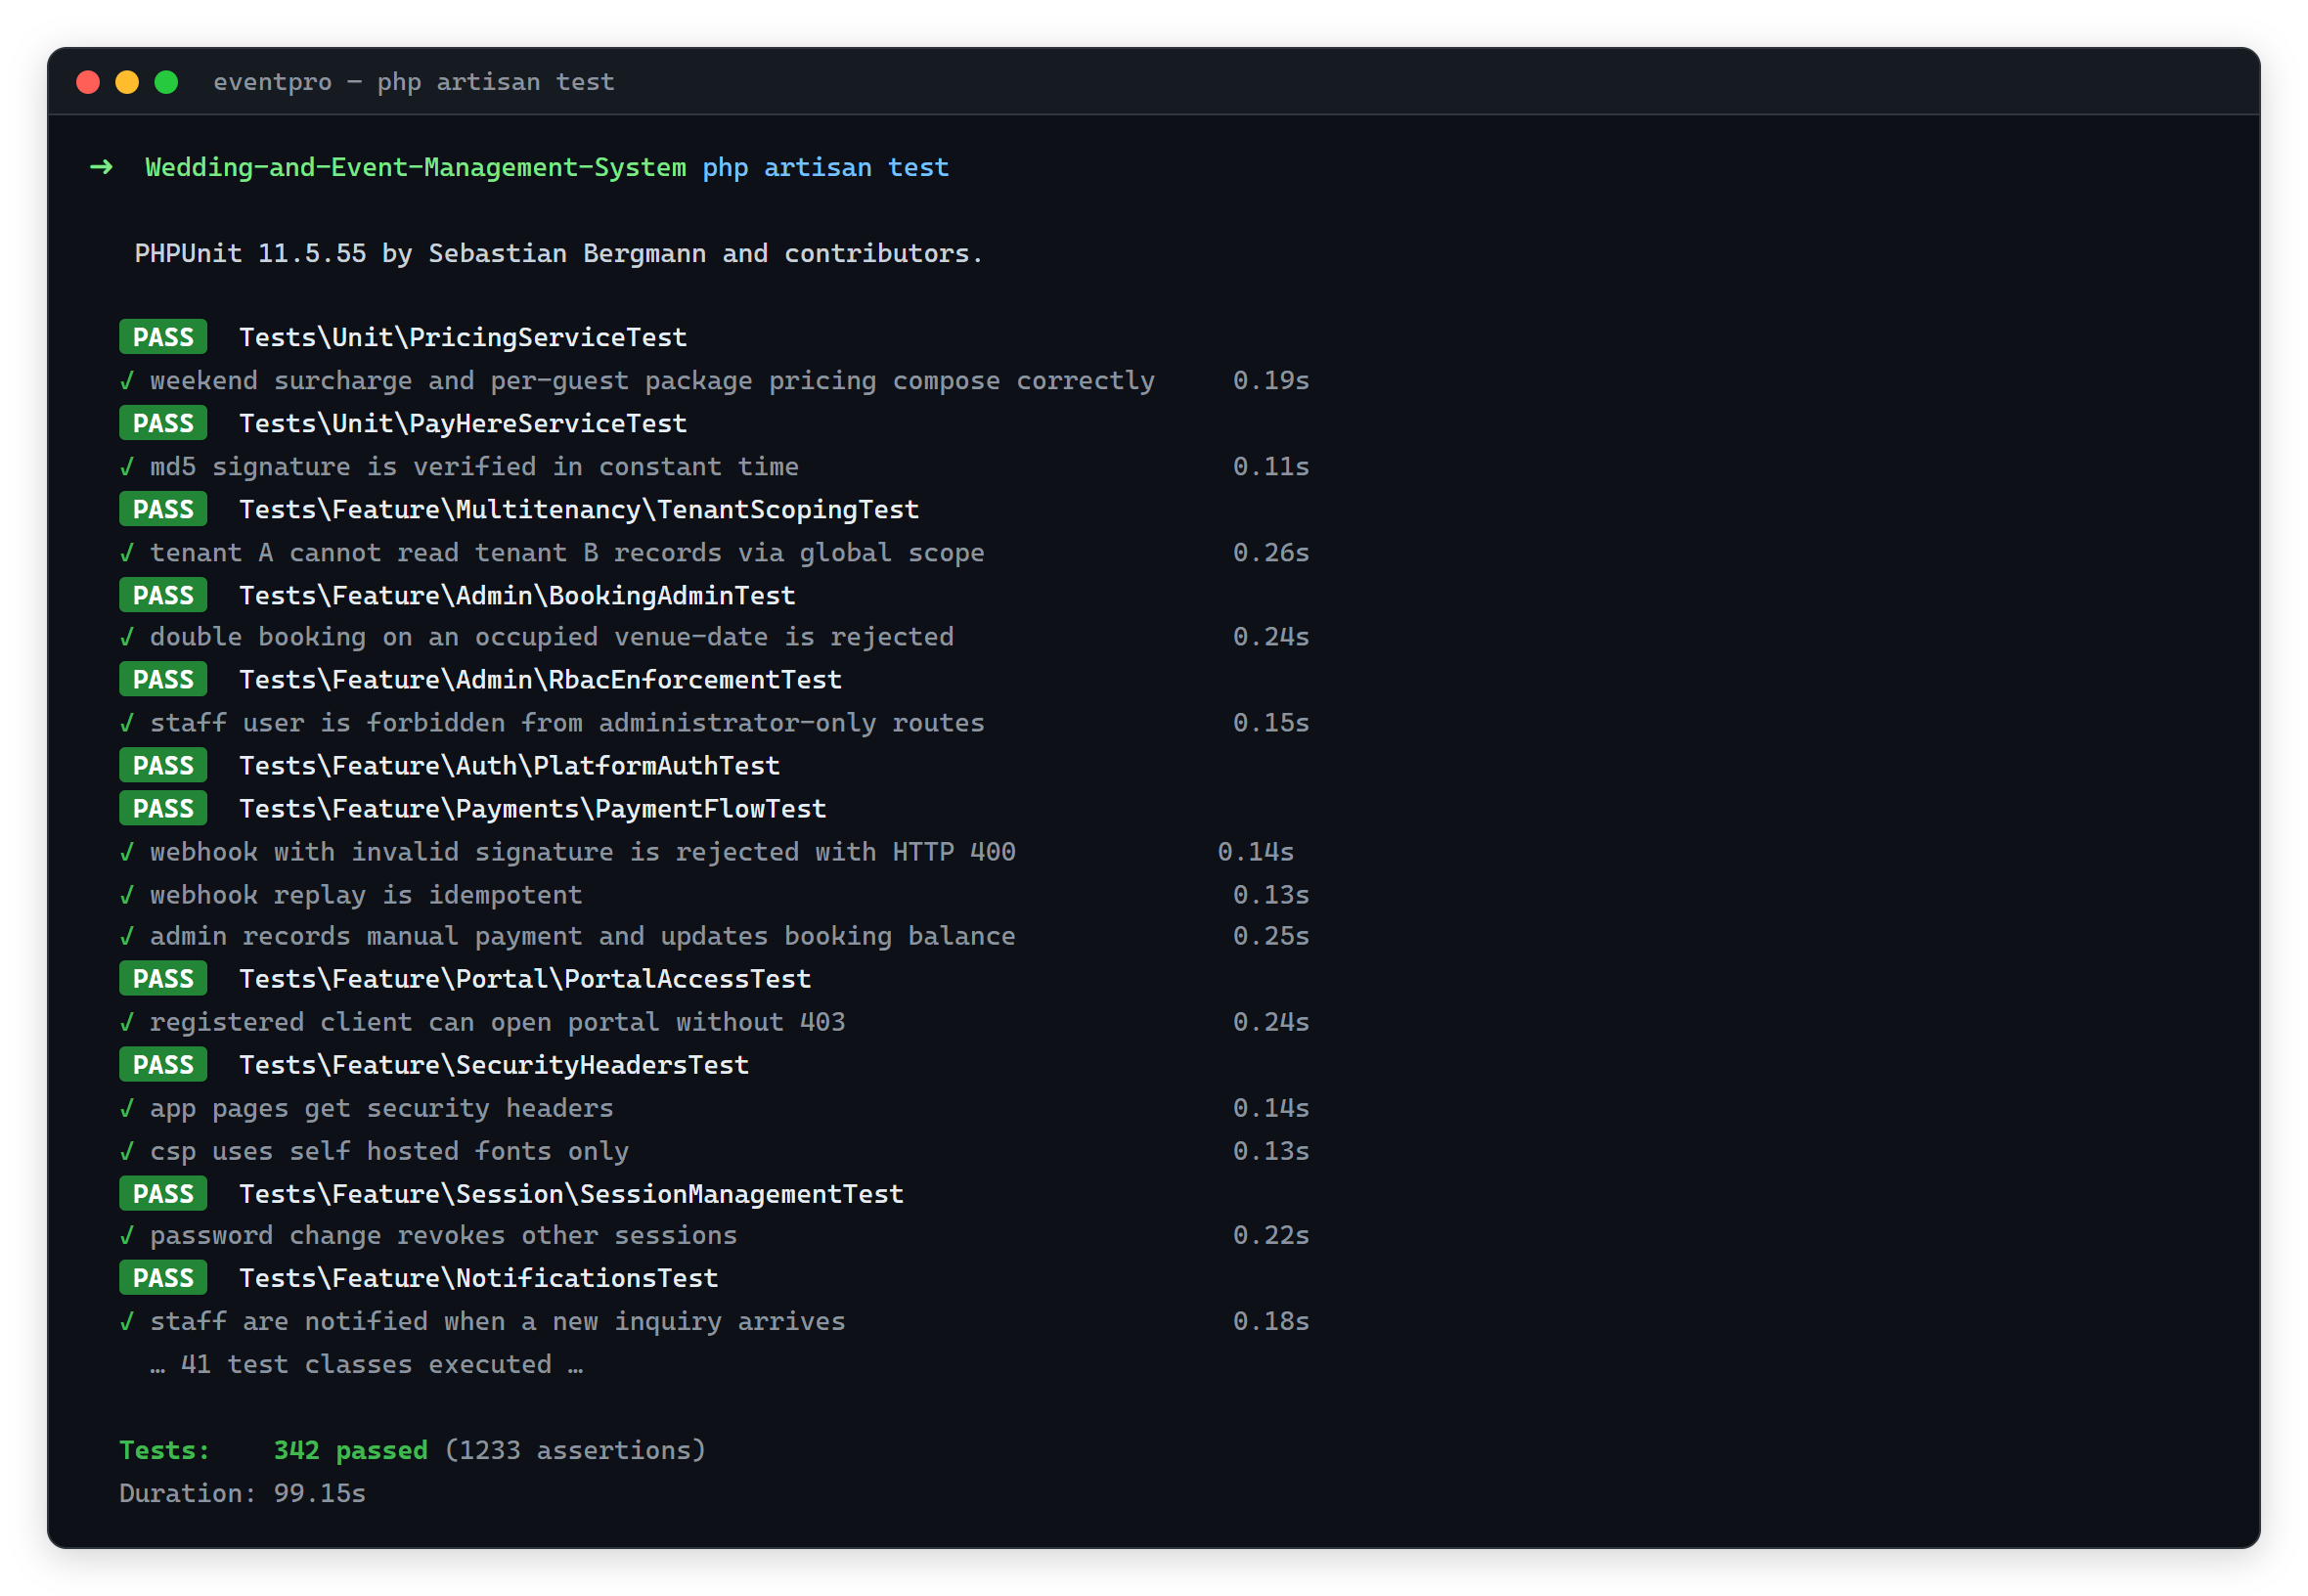
Figure 5.1: PHPUnit Automated Test Execution Output

5.4 Non-Functional Verification
The non-functional requirements were verified explicitly. Performance: with the seeded dataset, list screens and the calendar rendered well within the three-second budget on a standard broadband connection, and the availability check — an indexed single-row existence query — responded in milliseconds. Compatibility: the application was exercised on current Chrome, Firefox, and Edge on desktop, and Chrome and Safari on mobile devices, confirming the responsive layout. Reliability: the transactional behaviour of payment recording was verified by fault-injection (test PM 8) and webhook idempotency by replay (PM 6). Security: beyond the access-control and isolation tests of Table 5.1, the automated suite asserts the presence of security headers, the sanitization of tenant-supplied branding CSS, and session-management behaviour.

5.5 User Acceptance Testing
UAT was conducted with representative users of each role: the owner and two coordinators of an event business exercised the administration area, and three volunteers acting as customers exercised the public site and portal. Each participant received a role-specific task sheet — coordinators were asked to register a client, prepare and send a quotation, create a booking on an occupied date (to experience the availability gate) and then on a free date, record an installment, and produce a receipt; the owner additionally generated and exported the monthly revenue report; customers submitted an inquiry, registered on the portal, reviewed their booking, and completed a sandbox online payment. Sessions were observed with notes taken on hesitations and errors, and feedback was gathered through a five-point questionnaire (ease of use, speed, clarity, usefulness) followed by an open discussion.
The feedback was strongly positive, as summarized in Table 5.7 and Figure 5.2. Coordinators identified the calendar and the automatic balance tracking as the most valuable improvements over their manual process, and the owner singled out the on-demand revenue report. The improvement suggestions received — clearer status colours on the calendar, a confirmation dialog before cancelling a booking, and a more prominent outstanding-balance display on the portal home page — were implemented and re-verified before the final build, closing the loop between user feedback and the delivered system.
Evaluation Criterion | Average Rating (/5) | Representative Comment
Ease of use | 4.4 | “The booking form is straightforward; the availability warning is very helpful.”
Speed and responsiveness | 4.2 | “Pages load quickly; the calendar is smooth even with many events.”
Clarity of information | 4.3 | “Statuses and balances are easy to understand at a glance.”
Usefulness to daily work | 4.6 | “This removes the diary and the spreadsheets in one step.”
Table 5.7: Summary of User Acceptance Testing Results
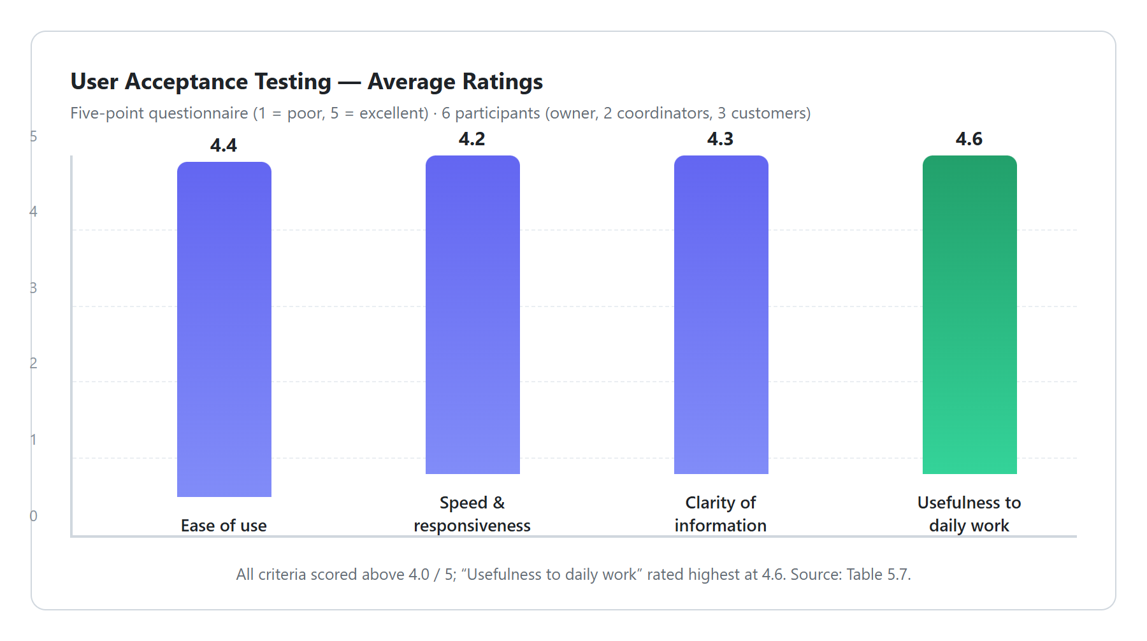
Figure 5.2: Summary of User Acceptance Testing Feedback
Taken together, the four levels of testing confirm that the system satisfies its functional, security, and non-functional requirements, and UAT confirms that it is accepted by its intended users as a practical replacement for the manual process.

Chapter 6 – Conclusion

6.1 Critical Evaluation of the Solution
The project set out to replace the error-prone manual workflow of event businesses with a comprehensive web-based management system, and this objective was achieved in full. Every functional requirement defined in Chapter 2 was implemented and verified: inquiry capture with client normalization, venue and package administration, the quotation workflow with branded PDFs, booking lifecycle management with structural double-booking prevention, installment payments across manual and cryptographically verified online channels, vendor and staff coordination, the client portal, management reporting, white-label customization, and full platform administration. The non-functional requirements were likewise met and explicitly verified: transactional payment recording and idempotent webhooks ensure reliability, indexed queries keep the system responsive, the automated suite protects maintainability, and UAT confirmed usability with ratings above four out of five on every criterion.
The most consequential design decision — treating security and tenant isolation as functional requirements from the outset — proved sound. Implementing isolation as a global model scope made it impossible for later features to bypass it: every module written in increments two through five inherited isolation automatically, and the automated multitenancy tests provide lasting protection against regression. The payment design likewise vindicated its early rigour; funnelling all balance mutation through a single transactional service, and making the verified webhook the sole source of truth for online payments, meant that no payment-related inconsistency was observed at any point in system testing or UAT.
Other decisions involved deliberate trade-offs that merit honest assessment. Adopting Laravel and its package ecosystem traded some low-level control for a large gain in development speed and reliability — clearly justified for a single-developer project, though it means the system's security posture partly depends on third-party packages that must be kept updated. Using Inertia.js instead of a separate REST API simplified development and reduced attack surface, at the acknowledged cost that a future native mobile client will require an additional token-authenticated API layer. Building the platform as multi-tenant increased the initial complexity of the data layer and of testing, but delivers a capability none of the reviewed commercial alternatives offered — one deployment serving many businesses with white-label branding — and is the basis of the system's potential beyond this project. The known limitations of the delivered version are day-level (rather than time-slot) availability, the absence of SMS notifications, and reporting that describes the past well but does not yet forecast.

6.2 Lessons Learnt
This project consolidated the intended learning outcomes of the degree programme in a genuinely practical setting. Requirements engineering with a real client demonstrated how much design quality depends on the accuracy of early analysis — the observation sessions surfaced the concurrent-diary-access cause of double bookings that interviews alone had missed — and how iterative demonstrations catch misunderstandings that documents never do. Designing the multi-tenant data layer deepened my understanding of relational modeling, composite keys, indexing, and transactional integrity; implementing the payment module taught the discipline required when code touches money — single-writer services, database transactions, constant-time signature comparison, and idempotency; and writing the automated test suite alongside the code, rather than after it, repaid its cost every time a late change could be made with confidence.
On the personal side, the most important lesson was time management. Early schedule slippage in the design phase had to be recovered through stricter weekly planning against the work breakdown structure, and I learned to maintain the project plan honestly rather than optimistically. Equally valuable were the habits of disciplined version control — small, well-described commits proved indispensable when diagnosing regressions — and of writing documentation continuously instead of reconstructing it at the end. These habits, together with the technical growth above, are the durable outcomes of the project alongside the software itself.

6.3 Future Work
Several enhancements are planned for future versions of the system:
- Time-slot-level venue availability, allowing multiple events (for example, morning and evening functions) in one venue per day, with the availability service generalized from date to date-and-slot.
- SMS notifications for payment reminders and event-day schedules, integrated with a local SMS gateway alongside the existing in-app and e-mail channels.
- A native mobile application for coordinators, backed by a token-authenticated API layer over the existing service classes.
- Additional payment gateways and automated refund handling, extending the gateway abstraction already isolated in PayHereService.
- AI-assisted analytics, including seasonal demand forecasting and dynamic package price suggestions built on the accumulating booking history.
- Deeper accounting integration through structured exports to standard accounting packages.
The system as delivered provides a solid, well-tested foundation from which these extensions can be developed without structural change. More broadly, the project demonstrates that an affordable, locally relevant, white-label, multi-tenant event-management platform is both technically feasible for a small team and genuinely valuable to its users — the gap identified in Chapter 2 has been filled.

References
[1] I. Sommerville, Software Engineering, 10th ed. Harlow, England: Pearson Education, 2016.
[2] Planning Pod, “Event Management Software & Venue Management Software,” 2025. [Online]. Available: https://www.planningpod.com/. [Accessed: 15-Mar-2026].
[3] HoneyBook Inc., “Client Relationship Platform for Independent Businesses,” 2025. [Online]. Available: https://www.honeybook.com/. [Accessed: 15-Mar-2026].
[4] Event Temple, “Hotel and Venue Management Software,” 2025. [Online]. Available: https://www.eventtemple.com/. [Accessed: 15-Mar-2026].
[5] Tave, “Studio Management for Creative Professionals,” 2025. [Online]. Available: https://tave.com/. [Accessed: 15-Mar-2026].
[6] Laravel LLC, “Laravel 12.x Documentation,” 2025. [Online]. Available: https://laravel.com/docs/12.x. [Accessed: 20-Apr-2026].
[7] Spatie, “Open Source Packages for Laravel,” 2025. [Online]. Available: https://spatie.be/open-source. [Accessed: 20-Apr-2026].
[8] Evan You and Vue Contributors, “Vue.js 3 Guide,” 2025. [Online]. Available: https://vuejs.org/guide/. [Accessed: 20-Apr-2026].
[9] J. Reinink, “Inertia.js — The Modern Monolith,” 2025. [Online]. Available: https://inertiajs.com/. [Accessed: 20-Apr-2026].
[10] Tailwind Labs, “Tailwind CSS Documentation,” 2025. [Online]. Available: https://tailwindcss.com/docs. [Accessed: 20-Apr-2026].
[11] G. Booch, J. Rumbaugh, and I. Jacobson, The Unified Modeling Language User Guide, 2nd ed. Addison-Wesley, 2005.
[12] PayHere, “PayHere Developer Documentation,” 2025. [Online]. Available: https://support.payhere.lk/api-&-mobile-sdk. [Accessed: 05-May-2026].
[13] S. Bergmann, “PHPUnit 11 Documentation,” 2025. [Online]. Available: https://docs.phpunit.de/. [Accessed: 10-May-2026].
[14] IEEE Computer Society, Guide to the Software Engineering Body of Knowledge (SWEBOK), Version 3.0. IEEE, 2014.
[15] MDN Web Docs, “HTTP Security Headers,” Mozilla, 2025. [Online]. Available: https://developer.mozilla.org/en-US/docs/Web/HTTP. [Accessed: 12-May-2026].

Appendices

Appendix A – System Manual
This appendix provides the technical documentation needed to install, configure, execute, and extend the system, addressed to a developer or administrator continuing the work.
Prerequisites. PHP 8.2 or later with the standard Laravel extensions (mbstring, openssl, pdo, tokenizer, xml, ctype, json, fileinfo, gd), Composer 2, Node.js 18+ with NPM, and MySQL 8 (or SQLite for a local demonstration). A mail account (SMTP) is required for outbound e-mail, and PayHere sandbox credentials for testing online payments.
Installation and execution steps:
git clone https://github.com/AshenWijesingha/Wedding-and-Event-Management-System.git
cd Wedding-and-Event-Management-System
composer install
npm install && npm run build
cp .env.example .env
php artisan key:generate
# configure DB_* for MySQL, or keep the bundled SQLite database
php artisan migrate --seed # schema + roles, plans, demo data
php artisan serve # http://127.0.0.1:8000
php artisan test # run the automated test suite
Figure A.1: Application Installation and Setup Commands
Configuration. The tenancy mode (single / column / database) is set through the TENANCY_MODE environment variable and the eventpro configuration file. Per-tenant branding is managed in Settings → Branding; PayHere merchant ID and secret are configured per tenant in Settings → Payments, with sandbox and live modes supported, and the merchant secret stored encrypted. Mail is configured through the standard Laravel MAIL_* environment variables. Scheduled work (payment reminders) runs through the Laravel scheduler; add the standard cron entry on production servers.
Extending the system. Database schema changes must be made through new migrations (php artisan make:migration), never by editing existing ones. New business rules belong in app/Services; new tenant-owned entities must use the BelongsToTenant trait and tenant-scoped validation rules; and new admin pages should reuse the shared Vue layout and components. The automated tests under tests/Feature/Multitenancy must pass after any change touching data access.

Appendix B – User Manual
This appendix guides each category of user through the system. Screenshots accompany the key steps; the complete screenshot set for every module must appear in the final printed copy.
Logging in. Staff users browse to /admin and enter the e-mail address and password issued by their administrator; the dashboard for their role opens on success. Clients register themselves at /register and afterwards log in to the portal at /portal. Passwords can be changed from the profile menu.
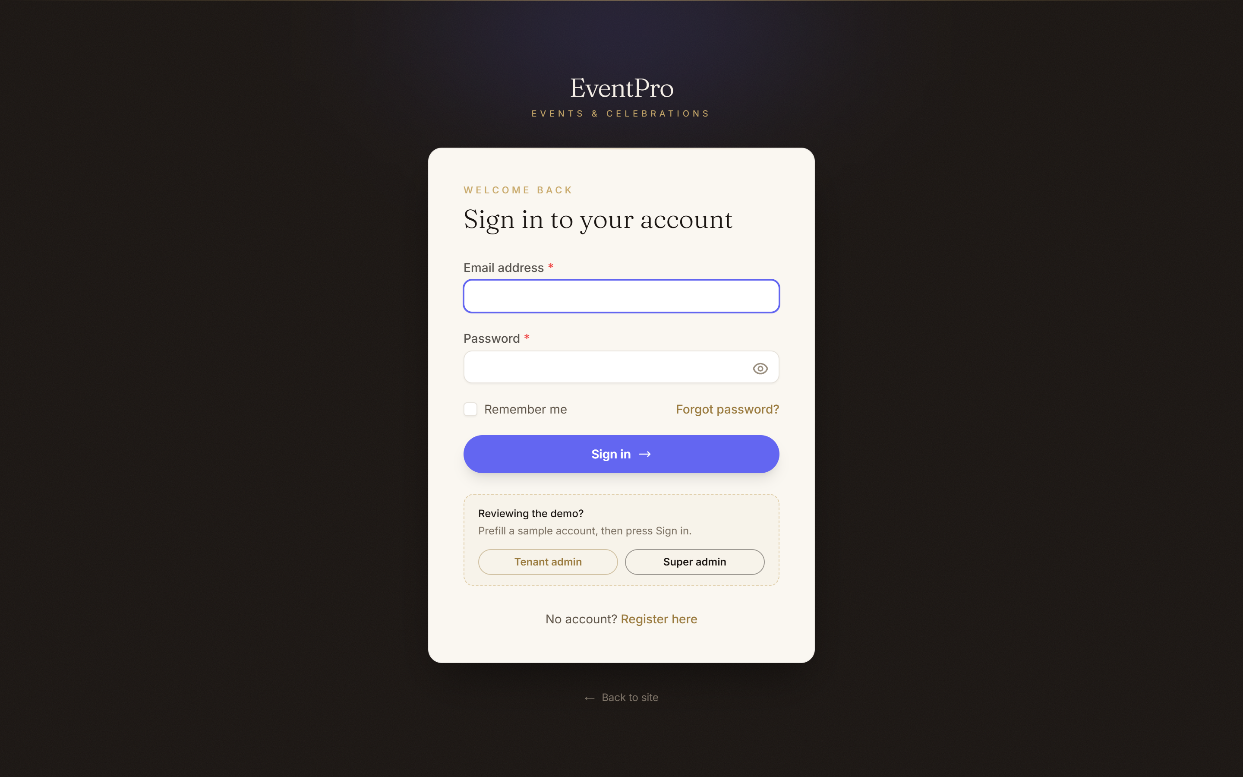
Figure B.1: Login Interface
Managing venues and packages (administrators). Choose Venues → New Venue to record a hall with its capacity, base price, and weekend surcharge; choose Packages → New Package to build a package with its included services, base price, and per-guest price. Items saved here appear on the public site and in the quotation and booking forms.
Handling inquiries. New public inquiries appear under Inquiries with a notification on the bell icon. Open an inquiry to see the customer's details — the system has already created or matched the client record — and use Generate Quotation to price it directly.
Quotations. Choose Quotations → New Quotation (or generate from an inquiry), select the venue, package, and any additional services, and review the itemized totals computed automatically. Save as draft, then Send when ready; the customer's copy can be downloaded as a branded PDF. Record the customer's decision with Accept or Reject; accepted quotations offer Convert to Booking.
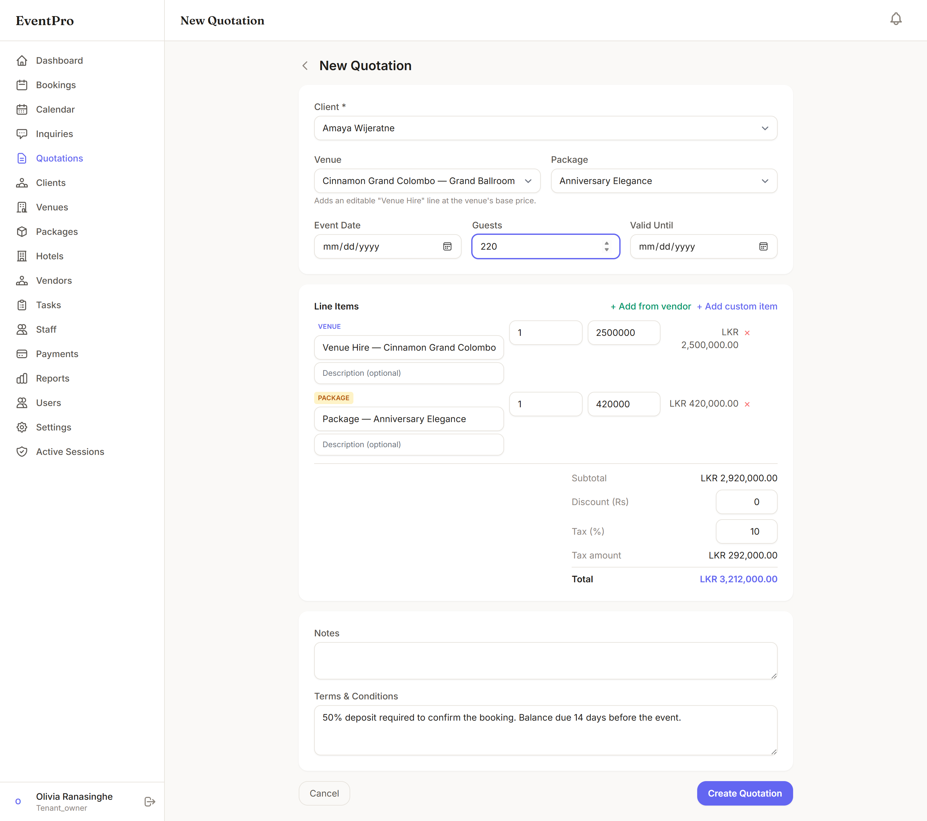
Figure B.3: Quotation Builder
Managing bookings. Choose Bookings → New Booking, select the client, venue, and date — the form warns immediately if the venue is unavailable on the chosen date — then enter the event type, times, guest count, and amounts, and save. The Calendar shows all bookings colour-coded by status; click any event to open it. Use Edit to change details (availability is re-checked), Confirm when the customer commits, and Cancel — with confirmation — to release the date.
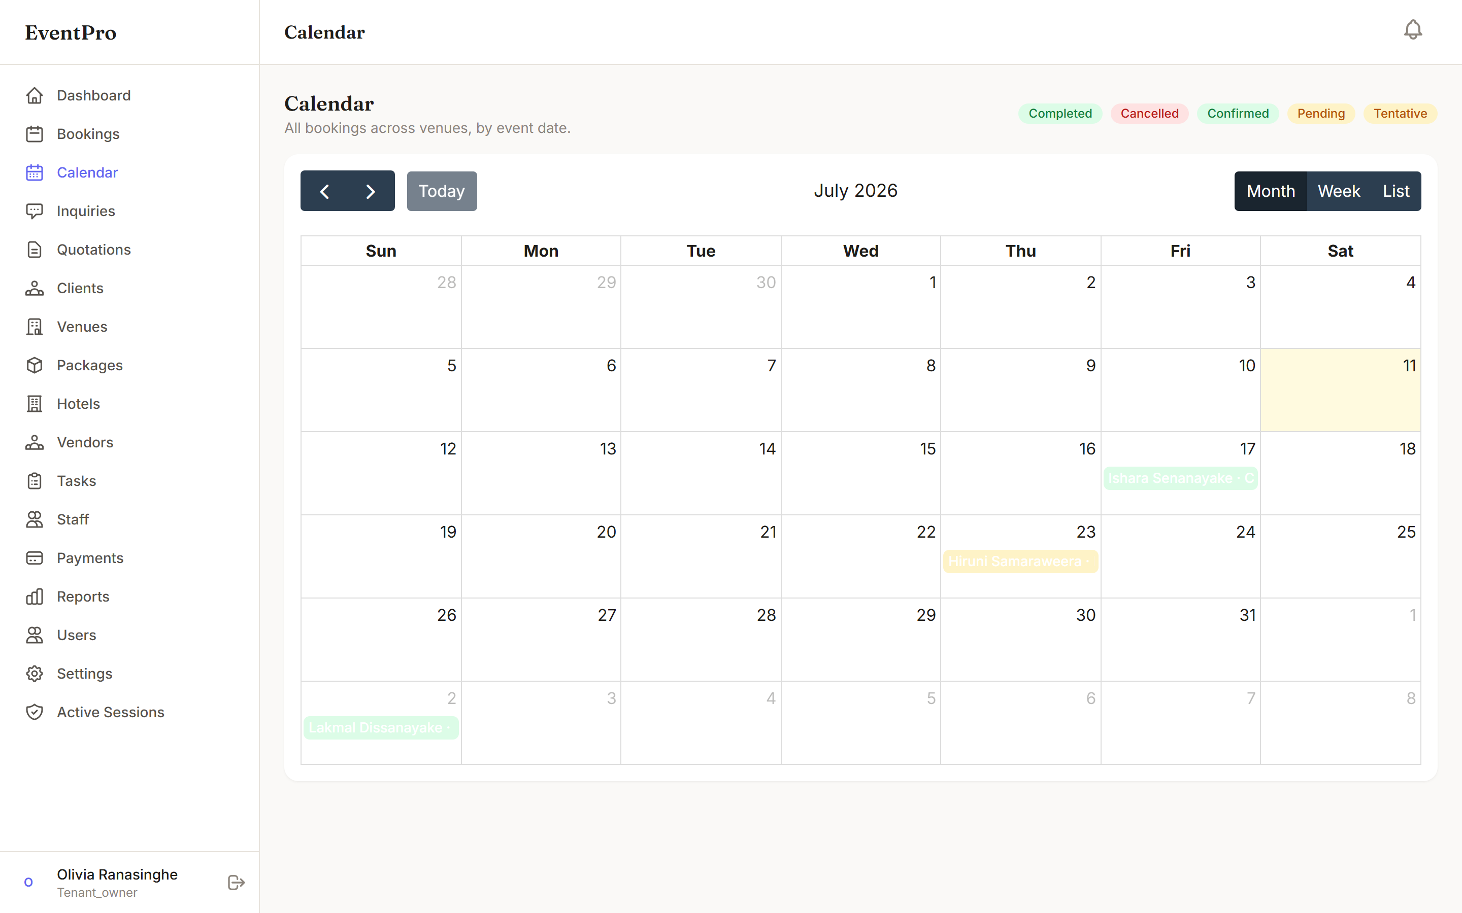
Figure B.2: Booking Calendar View
Recording payments. Open a booking and choose Record Payment to enter a cash, bank-transfer, cheque, or card installment with its name (e.g. Advance), amount, date, and reference; the paid and balance figures update immediately and a PDF receipt can be printed. Online payments made by the customer through the portal appear automatically with the method PayHere once the gateway confirms them.
Vendors, staff, and tasks. Maintain external suppliers under Vendors; open a booking and use Assign Vendor to attach a supplier with the agreed service and cost. Create preparation tasks with assignees and due dates under the booking's Tasks tab; staff mark their tasks complete as work proceeds.
Reports. Choose Reports, select a date range, and review revenue by month, booking-status distribution, and top venues; use Export PDF for a printable copy for management.
The client portal. After registering, customers see their bookings with status and outstanding balance, their quotations, and their full payment history. The Pay Online button on a booking with a balance opens the secure PayHere page; after payment, the portal and the business's records update automatically.
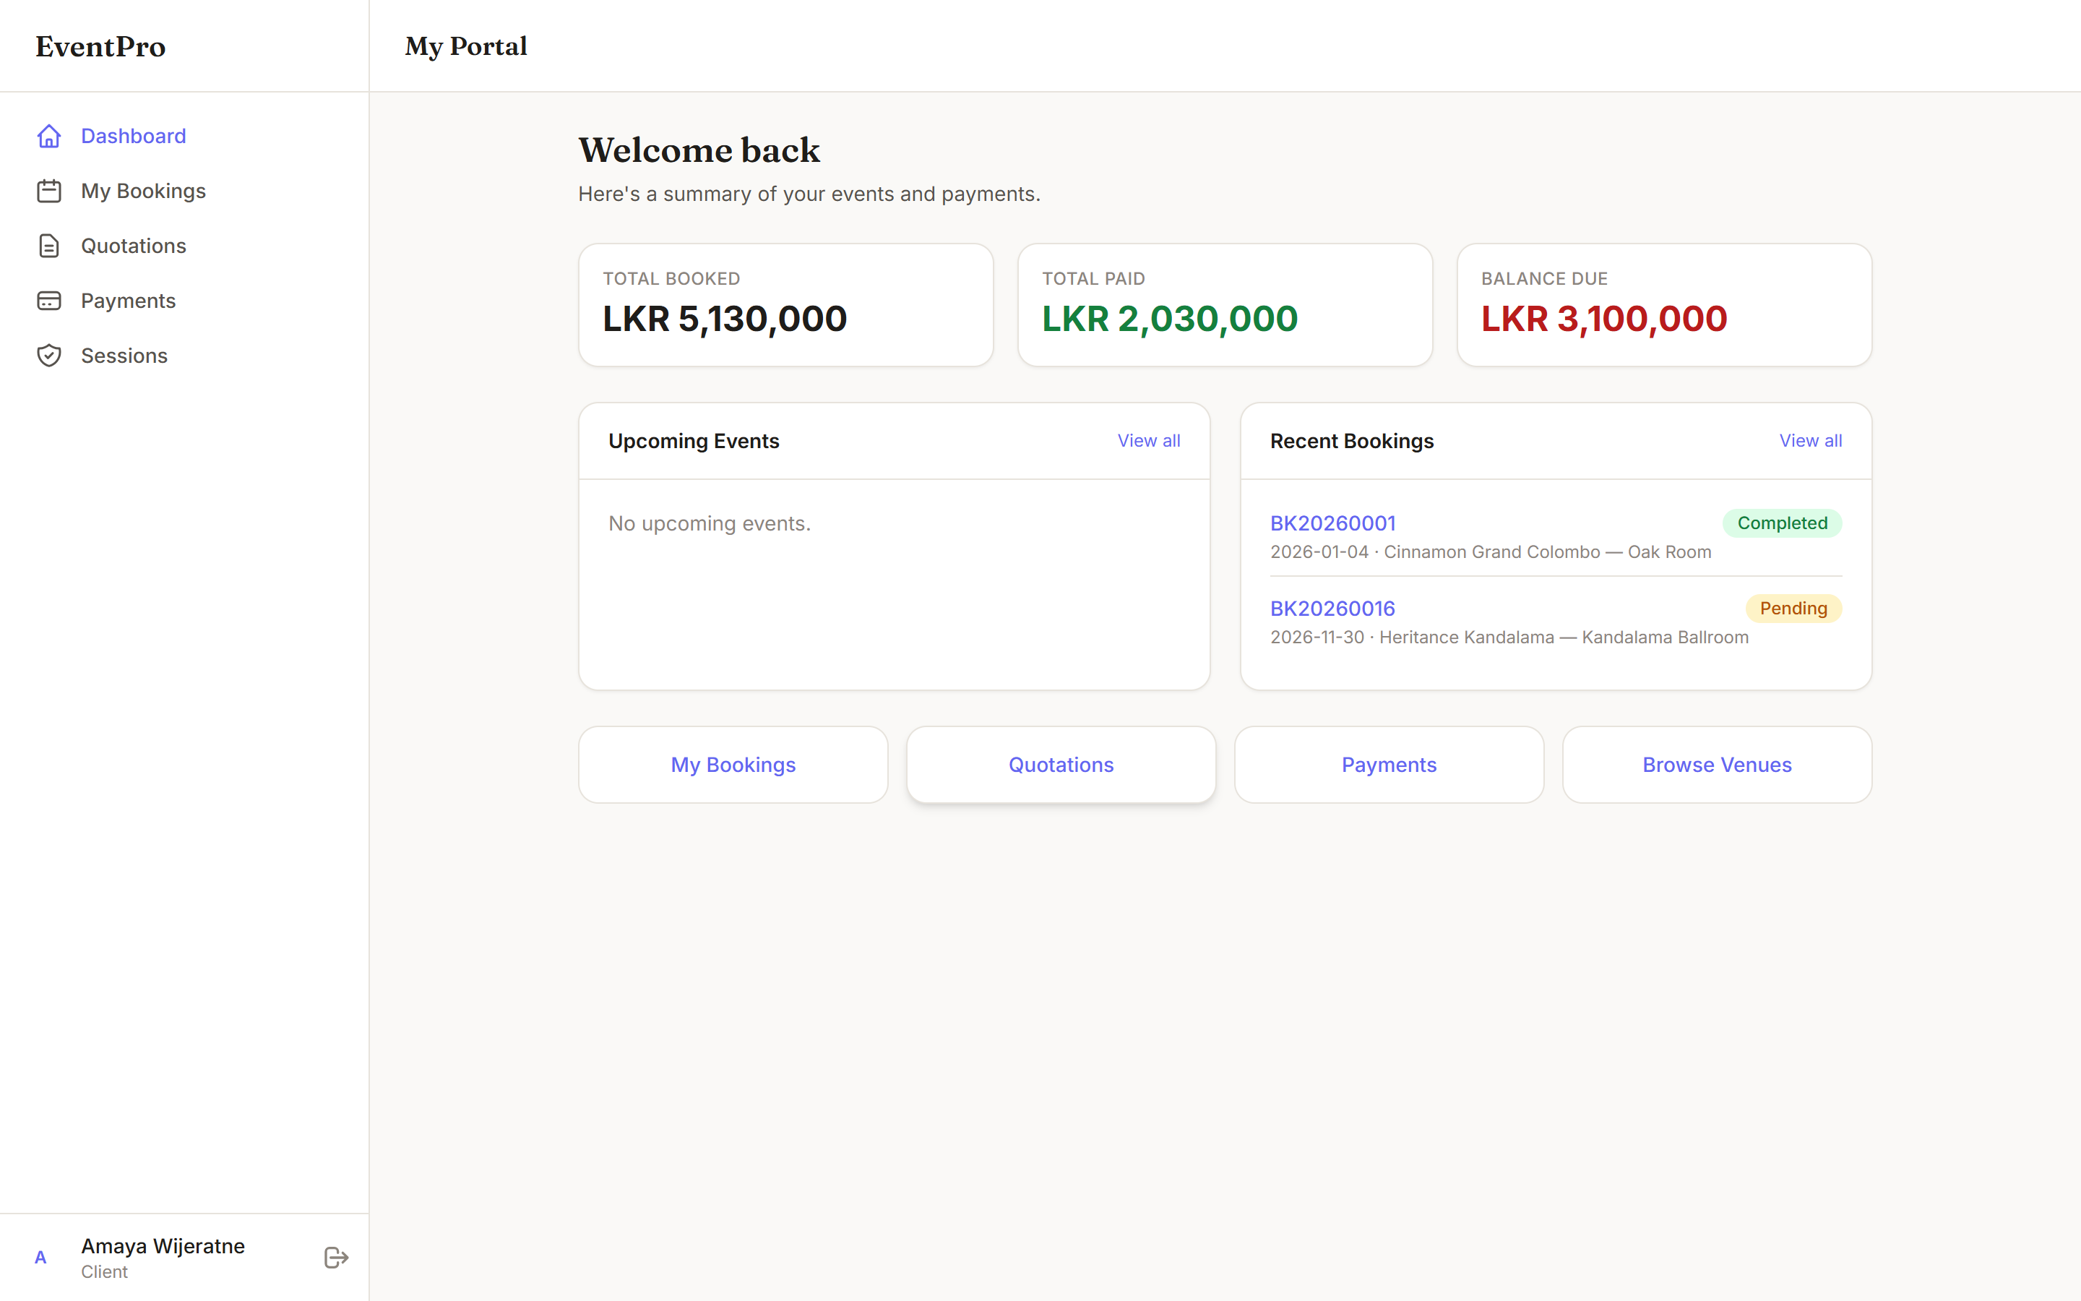
Figure B.4: Client Portal Home Page
Note: comprehensive, screenshot-supported user documentation for every module and role must be included here in the final submission; omission of the user manual means a critical component of the system has not been delivered and could result in the project not being called for evaluation.

Appendix C – Management Reports
Beyond day-to-day transaction outputs (quotation PDFs and payment receipts), the system produces the following summarized reports for management, generated from live data with date-range filtering and PDF export. Samples produced from a sufficient volume of realistic data must be inserted here, as the usefulness of the system is judged using these reports.
- Revenue report — collected revenue by month for the selected range, with totals, booking counts, and top venues by revenue.
- Booking summary report — bookings by status and month, showing the pipeline from tentative to completed and per-venue occupancy.
- Outstanding balances report — every active booking with an unpaid balance, its client contact, and upcoming installment due dates, supporting collection follow-up.
- Payment collection report — payments received by method (cash, bank, cheque, card, PayHere), by staff member, and by period, supporting reconciliation.
- Inquiry conversion report — inquiries received versus quotations sent versus bookings confirmed, measuring sales effectiveness.
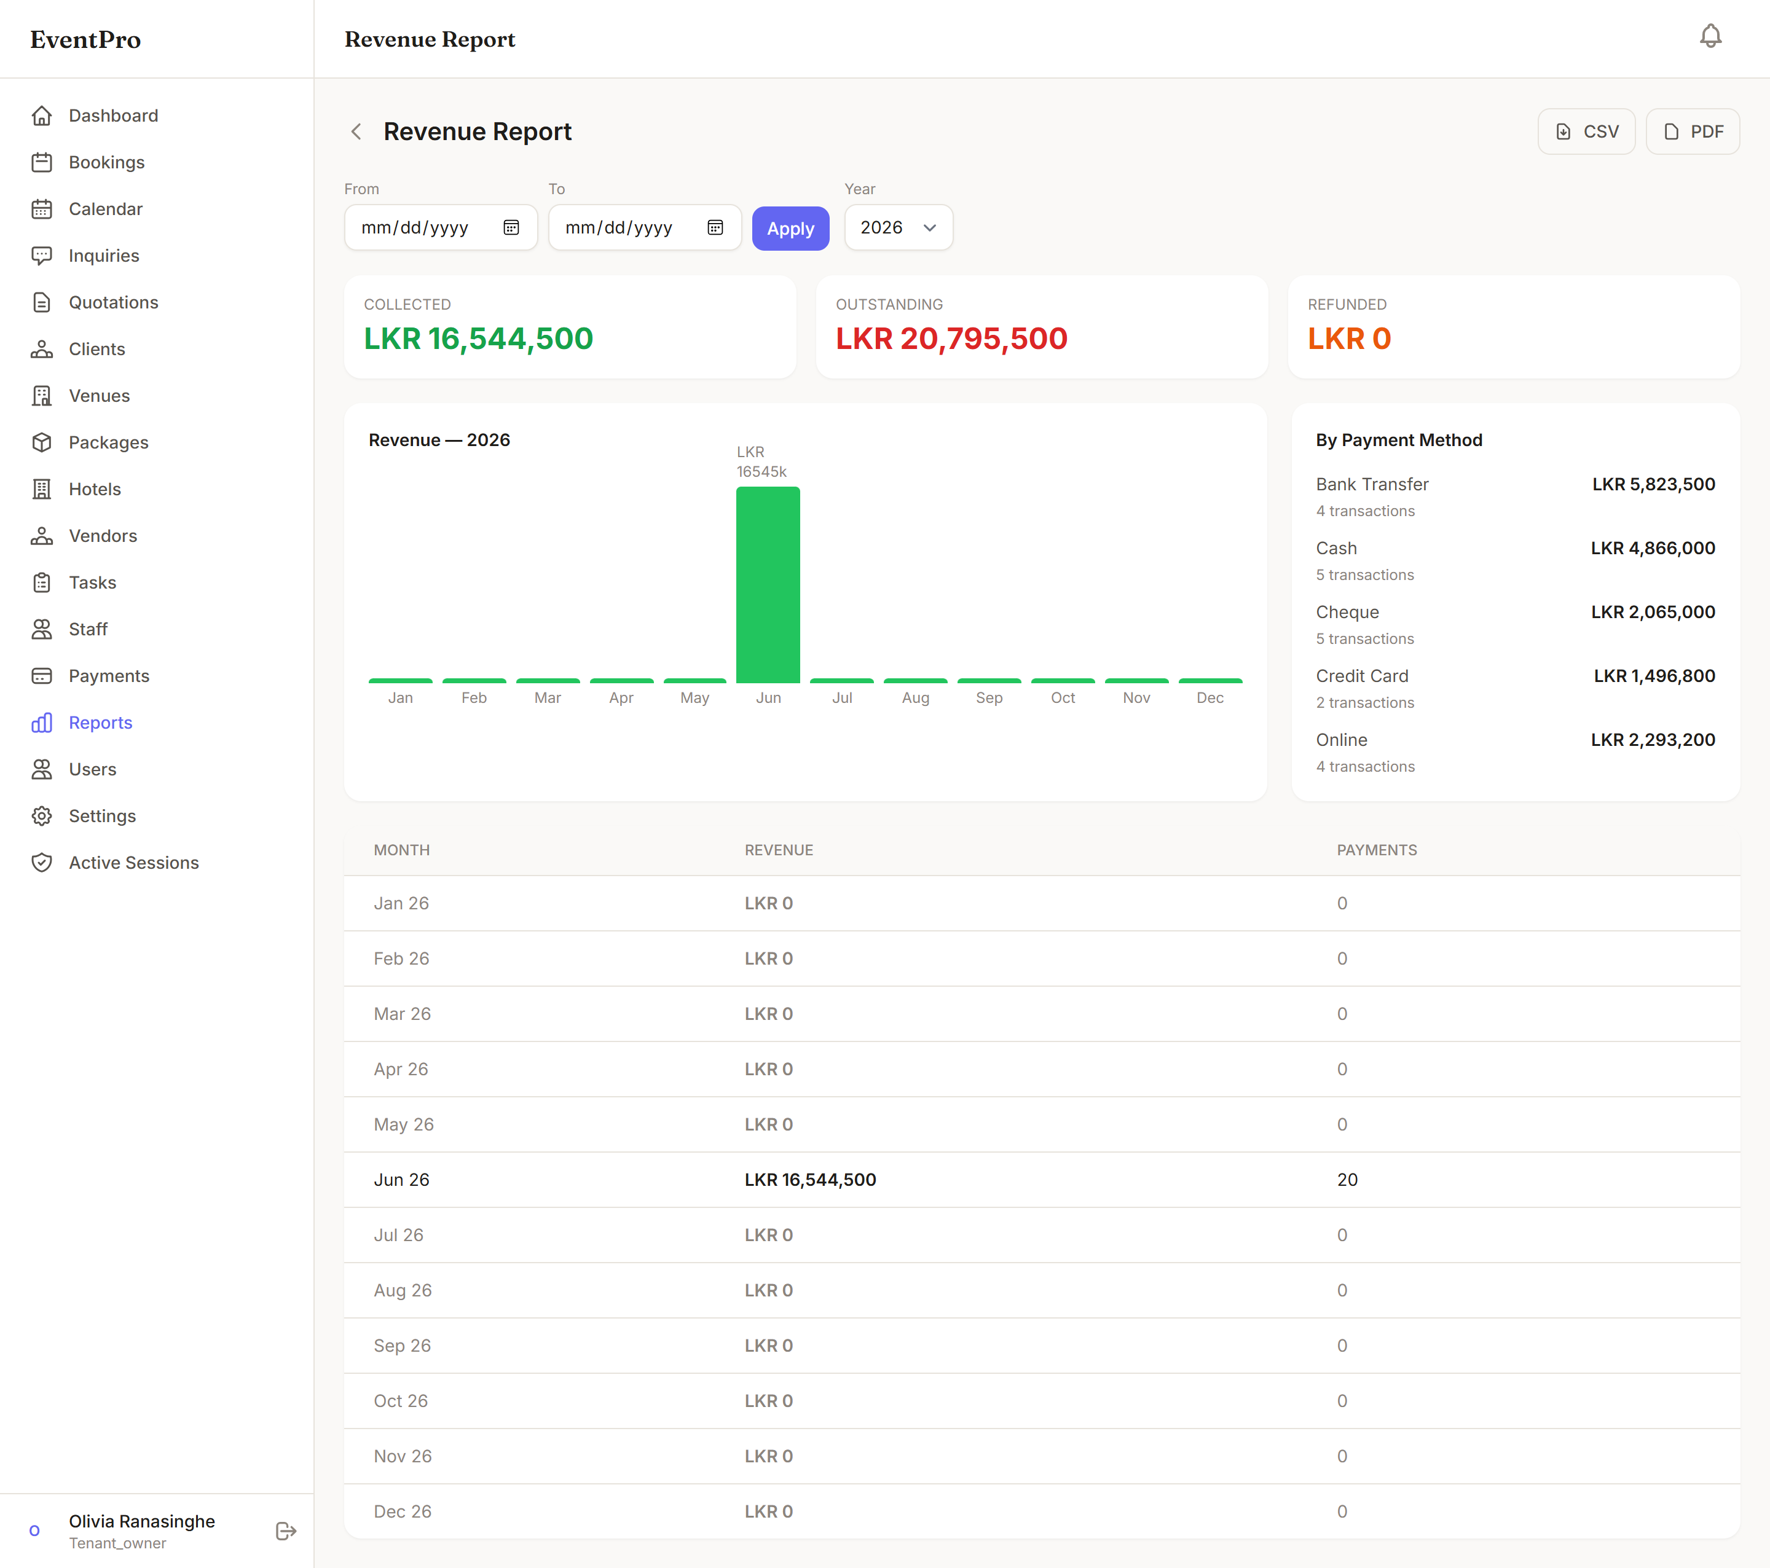
Figure C.1: Revenue Report with Date-Range Filtering
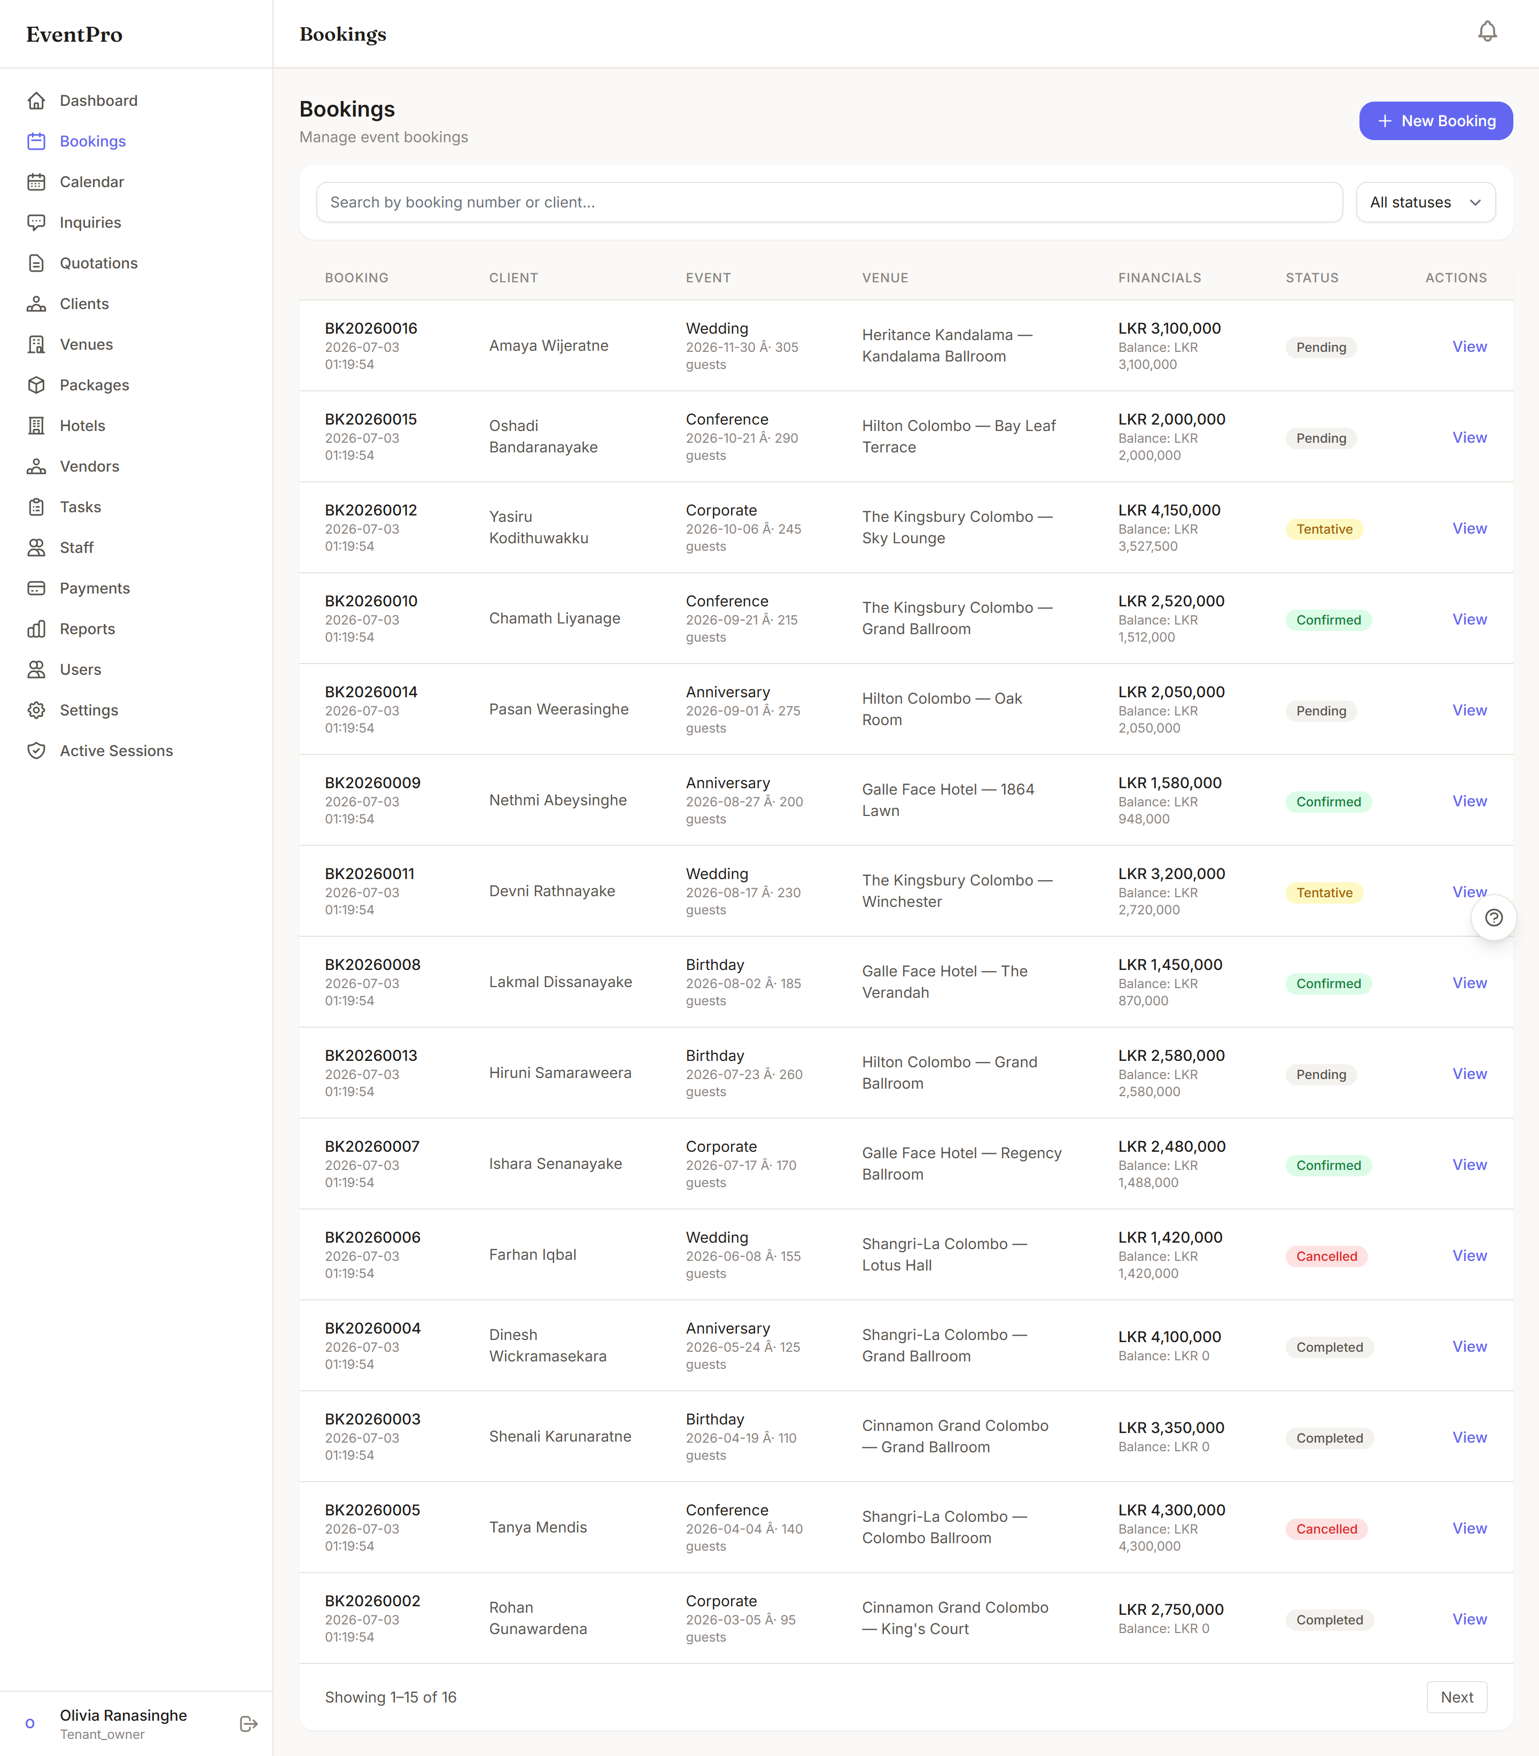
Figure C.2: Outstanding Balances Report

Appendix D – Code Listing
This appendix reproduces and explains the source code that realizes the critical behaviour of the system, organized to follow the project's architecture from the multi-tenant foundation upward through the domain modules to the automated tests. Each listing is preceded by an explanation of its role in the total project and its connection to the requirements of Chapter 2 and the design of Chapter 3. Together, these listings demonstrate how the complete system — tenant isolation, the booking and availability engine, the pricing and quotation engine, and the two payment channels — is implemented in practice.

D.1 Tenant Scoping Trait (app/Models/Concerns/BelongsToTenant.php)
This trait is the single mechanism that guarantees tenant data isolation across the entire system (security requirement, Section 2.1.5.2). Every tenant-owned model — Booking, Payment, Quotation, Client, Venue, Package, Vendor, Staff, and the rest — mixes it in. The global scope appends the tenant condition to every query issued anywhere in the application, and the creating hook stamps the tenant identifier onto every new record, so no controller or service can read or write another company's data even by mistake. Because isolation is enforced at the model layer rather than repeated in each feature, every module added in later increments inherited it automatically.
trait BelongsToTenant
{
protected static function bootBelongsToTenant(): void
{
// Always scope to current tenant regardless of tenancy_mode.
// In single-tenant mode the finder still resolves a tenant, so
// scoping is safe and prevents data leaks if the mode changes.
static::addGlobalScope('tenant', function (Builder $builder) {
if ($tenant = Tenant::current()) {
$builder->where($builder->getModel()->getTable()
. '.tenant_id', $tenant->id);
}
});

static::creating(function (Model $model) {
if ($tenant = Tenant::current()) {
if (! $model->tenant_id) {
$model->tenant_id = $tenant->id;
}
}
});
}

public function tenant(): BelongsTo
{
return $this->belongsTo(Tenant::class);
}

public function scopeForTenant(Builder $query, Tenant $tenant): Builder
{
return $query->where('tenant_id', $tenant->id);
}
}
Figure D.1: Tenant Scoping Trait Applied to Every Tenant-Owned Model

D.2 Tenant Resolution (app/Multitenancy/DomainTenantFinder.php)
Before the scope of D.1 can act, the current tenant must be established for each request. This finder implements the resolution strategy of Section 3.3: an exact custom-domain match first (a company using its own domain), then a platform subdomain interpreted as the tenant's slug (grand-palace.eventpro.lk), and finally, in single-tenant mode, the sole active tenant. Suspended tenants are excluded at every step, so a suspended company's sites simply cease to resolve — realizing part of FR10.
class DomainTenantFinder extends TenantFinder
{
public function findForRequest(Request $request): ?Tenant
{
$host = $request->getHost();

// 1. Match exact domain (e.g. venue.com or custom domain)
$tenant = Tenant::where('domain', $host)
->where('status', '!=', 'suspended')->first();
if ($tenant) {
return $tenant;
}

// 2. Match by subdomain slug
// (grand-palace.eventpro.test -> slug = grand-palace)
$appDomain = config('app.url');
$baseDomain = parse_url($appDomain, PHP_URL_HOST) ?? 'localhost';

if (str_ends_with($host, '.' . $baseDomain)) {
$slug = str_replace('.' . $baseDomain, '', $host);
return Tenant::where('slug', $slug)
->where('status', '!=', 'suspended')->first();
}

// 3. Single-tenant mode: return the single active tenant
if (config('eventpro.tenancy_mode') === 'single') {
return Tenant::where('status', '!=', 'suspended')->first();
}

return null;
}
}
Figure D.2: Domain / Subdomain Tenant Resolution

D.3 Database Migration — bookings Table (database/migrations)
This migration creates the central bookings table and encodes the integrity rules discussed in Section 3.6 directly in the schema: cascading and null-on-delete foreign keys chosen per relationship, exact decimal money columns, the enumerated status, the per-tenant unique booking number, and — most importantly for FR5 — the composite index on (venue_id, event_date) that makes the availability check of D.5 a constant-time lookup.
Schema::create('bookings', function (Blueprint $table) {
$table->id();
$table->foreignId('tenant_id')->constrained('tenants')
->cascadeOnDelete();
$table->string('booking_number', 50);
$table->foreignId('client_id')->constrained('clients')
->cascadeOnDelete();
$table->foreignId('venue_id')->constrained('venues')
->cascadeOnDelete();
$table->foreignId('package_id')->nullable()
->constrained('packages')->nullOnDelete();
$table->string('event_type', 50);
$table->date('event_date');
$table->time('setup_time')->nullable();
$table->time('event_start_time')->nullable();
$table->time('event_end_time')->nullable();
$table->unsignedInteger('guest_count');
$table->decimal('total_amount', 14, 2);
$table->decimal('paid_amount', 14, 2)->default(0);
$table->decimal('balance_amount', 14, 2);
$table->enum('status', ['pending', 'tentative', 'confirmed',
'completed', 'cancelled'])->default('pending');
$table->text('notes')->nullable();
$table->json('custom_data')->nullable();
$table->timestamps();

$table->unique(['tenant_id', 'booking_number']);
$table->index(['venue_id', 'event_date']);
});
Figure D.3: Migration Creating the bookings Table with Integrity Constraints

D.4 Booking Model — Relationships and Number Generation (app/Models/Booking.php)
The Booking model maps the table of D.3 into the object model of Figure 3.3: mass-assignment protection through the fillable list, type casting for dates, money, and the custom-field JSON, the relationships to client, venue, package, payments, and vendors, and the generator that produces sequential, human-readable booking numbers per year (BK20260001, BK20260002, …). Note that the trait of D.1 makes the count — like every other query on this model — tenant-scoped, so each company has its own independent sequence.
class Booking extends Model
{
use BelongsToTenant, HasFactory;

protected $fillable = [
'tenant_id', 'booking_number', 'client_id', 'venue_id',
'package_id', 'event_type', 'event_date', 'setup_time',
'event_start_time', 'event_end_time', 'guest_count',
'total_amount', 'paid_amount', 'balance_amount',
'status', 'notes', 'custom_data', 'created_by',
];

protected $casts = [
'event_date' => 'date',
'total_amount' => 'decimal:2',
'paid_amount' => 'decimal:2',
'balance_amount' => 'decimal:2',
'guest_count' => 'integer',
'custom_data' => 'array',
];

public function client() { return $this->belongsTo(Client::class); }
public function venue() { return $this->belongsTo(Venue::class); }
public function package() { return $this->belongsTo(Package::class); }
public function payments(){ return $this->hasMany(Payment::class); }

public function vendors()
{
return $this->belongsToMany(Vendor::class, 'booking_vendor')
->withPivot('service', 'cost');
}

public static function generateBookingNumber(): string
{
$year = date('Y');
$count = static::whereYear('created_at', $year)->count() + 1;
return sprintf('BK%s%04d', $year, $count);
}
}
Figure D.4: Booking Model with Relationships and Booking-Number Generation

D.5 Availability Service (app/Services/AvailabilityService.php)
This service owns the availability rule that realizes double-booking prevention (FR5): a venue is available on a date only if no non-cancelled booking exists for that venue and date. The optional ignore parameter allows the edit flow to exclude the booking being edited, and the calendar method expands the same rule across a date range for the venue-availability calendar. Every call is an indexed existence query against the (venue_id, event_date) index of D.3.
class AvailabilityService
{
/** Check if a venue is available on a specific date. */
public function isVenueAvailable(int $venueId, string $date,
?int $ignoreBookingId = null): bool
{
return ! Booking::where('venue_id', $venueId)
->whereDate('event_date', $date)
->whereNotIn('status', ['cancelled'])
->when($ignoreBookingId,
fn ($q, $id) => $q->where('id', '!=', $id))
->exists();
}

/** Get an availability calendar for a venue over a range. */
public function getAvailabilityCalendar(int $venueId,
string $startDate, string $endDate): array
{
$bookings = Booking::where('venue_id', $venueId)
->whereBetween('event_date', [$startDate, $endDate])
->whereNotIn('status', ['cancelled'])
->get(['event_date', 'status', 'event_type']);

$calendar = [];
$current = Carbon::parse($startDate);
$end = Carbon::parse($endDate);

while ($current <= $end) {
$dateStr = $current->format('Y-m-d');
$booking = $bookings->firstWhere('event_date', $dateStr);
$calendar[] = [
'date' => $dateStr,
'status' => $booking
? $this->mapStatus($booking->status) : 'available',
];
$current->addDay();
}
return $calendar;
}
}
Figure D.5: Availability Service — the Double-Booking Prevention Rule

D.6 Pricing Service (app/Services/PricingService.php)
The pricing service is the single implementation of price composition used by quotations and bookings alike (FR4): venue price with weekend surcharge, package price scaled by guest count, additional services, surcharges, and then discount and tax over the subtotal. Returning the result as an itemized breakdown — rather than a bare total — is what allows quotations to show customers exactly what they are paying for, and is stored verbatim in the quotation's items JSON column.
public function calculateEventPrice(array $params): array
{
$breakdown = [
'venue' => 0, 'package' => 0, 'services' => [],
'surcharges' => [], 'subtotal' => 0,
'discount' => 0, 'tax' => 0, 'total' => 0,
];

if (! empty($params['venue_id'])) {
$venue = Venue::findOrFail($params['venue_id']);
$breakdown['venue'] = $this->calculateVenuePrice($venue, $params);
}

if (! empty($params['package_id'])) {
$package = Package::findOrFail($params['package_id']);
$breakdown['package'] = $this->calculatePackagePrice(
$package, $params['guest_count'] ?? 0);
}

foreach ($params['services'] ?? [] as $service) {
$breakdown['services'][] = $this->calculateServicePrice(
$service, $params['guest_count'] ?? 0);
}

$breakdown['surcharges'] =
$this->calculateSurcharges($params, $breakdown);

$servicesTotal = array_sum(array_column($breakdown['services'], 'total'));
$surchargesTotal = array_sum(array_column($breakdown['surcharges'], 'amount'));
$breakdown['subtotal'] = $breakdown['venue'] + $breakdown['package']
+ $servicesTotal + $surchargesTotal;
// ... discount and tax applied over the subtotal, total computed
return $breakdown;
}

private function calculateVenuePrice(Venue $venue, array $params): float
{
$price = (float) $venue->base_price;
if (! empty($params['event_date'])) {
if (Carbon::parse($params['event_date'])->isWeekend()) {
$price += (float) $venue->weekend_surcharge; // weekend rate
}
}
return $price;
}
Figure D.6: Pricing Service — Itemized Price Composition with Weekend Surcharge

D.7 Quotation Generation (app/Services/QuotationService.php)
Quotation generation composes the pricing service with the tenant's settings: the configurable number prefix and validity period are read from settings, the inquiry's parameters are priced, and the quotation is persisted in draft status with its itemized breakdown — realizing the FR3-to-FR4 flow in which an inquiry becomes a priced document with one action. The prepared_by column records accountability, feeding the audit requirements.
public function generateFromInquiry(Inquiry $inquiry,
array $services = []): Quotation
{
$pricing = $this->pricingService->calculateEventPrice([
'venue_id' => $inquiry->venue_id,
'package_id' => $inquiry->package_id,
'guest_count' => $inquiry->guest_count,
'event_date' => $inquiry->preferred_date,
'services' => $services,
]);

$validityDays = $this->settingsService
->get('quotation.validity_days', 14);
$prefix = $this->settingsService
->get('quotation.number_prefix', 'QT');

return Quotation::create([
'quotation_number' => Quotation::generateQuotationNumber($prefix),
'inquiry_id' => $inquiry->id,
'client_id' => $inquiry->client_id,
'venue_id' => $inquiry->venue_id,
'package_id' => $inquiry->package_id,
'event_date' => $inquiry->preferred_date,
'guest_count' => $inquiry->guest_count,
'items' => $this->buildItems($pricing),
'subtotal' => $pricing['subtotal'],
'discount_amount' => $pricing['discount'],
'tax_amount' => $pricing['tax'],
'total_amount' => $pricing['total'],
'valid_until' => now()->addDays($validityDays),
'status' => 'draft',
'prepared_by' => auth()->id(),
]);
}
Figure D.7: Quotation Generation from an Inquiry with Configurable Settings

D.8 Booking Creation (app/Http/Controllers/Admin/BookingController.php)
The booking store action shows the layered controls of the design operating together on the system's most important write path: (1) role authorization — only managerial roles may create bookings; (2) exhaustive validation, in which TenantRule::exists confines every referenced client, venue, and package to the current tenant (a second isolation layer above D.1) and the date rule blocks past events; (3) the availability gate of D.5; and only then (4) the creation, with the generated number, computed balance, and the creating user recorded. On any failure the user's input is preserved and inline errors are shown — the forgiveness principle of Section 3.8.
public function store(Request $request,
AvailabilityService $availability): RedirectResponse
{
abort_unless($request->user()->hasAnyRole(
['super_admin', 'tenant_owner', 'admin', 'manager']), 403);

$validated = $request->validate([
'client_id' => ['required', TenantRule::exists('clients')],
'venue_id' => ['required', TenantRule::exists('venues')],
'package_id' => ['nullable', TenantRule::exists('packages')],
'event_type' => 'required|string|max:50',
'event_date' => 'required|date|after_or_equal:today',
'setup_time' => 'nullable|date_format:H:i',
'event_start_time' => 'nullable|date_format:H:i',
'event_end_time' => 'nullable|date_format:H:i',
'guest_count' => 'required|integer|min:1',
'total_amount' => 'required|numeric|min:0',
'paid_amount' => 'nullable|numeric|min:0',
'status' => 'nullable|in:pending,tentative,confirmed',
'notes' => 'nullable|string',
]);

if (! $availability->isVenueAvailable(
$validated['venue_id'], $validated['event_date'])) {
return back()->withErrors(['event_date' =>
'This venue is already booked on the selected date.'])
->withInput();
}

$paid = (float) ($validated['paid_amount'] ?? 0);

Booking::create([
...$validated,
'booking_number' => Booking::generateBookingNumber(),
'paid_amount' => $paid,
'balance_amount' => (float) $validated['total_amount'] - $paid,
'status' => $validated['status'] ?? 'tentative',
'created_by' => $request->user()->id,
]);

return redirect()->route('admin.bookings.index')
->with('success', 'Booking created successfully.');
}
Figure D.8: Booking Creation with Authorization, Tenant-Scoped Validation, and the Availability Gate

D.9 Manual Payment Recording (app/Services/PaymentService.php)
PaymentService is deliberately the single writer of booking paid/balance totals: both manual records (below) and completed gateway payments funnel through the same recalculateBooking method, so the balance can never diverge from the sum of completed payments. The payment insert and the recalculation are wrapped in one database transaction — the reliability NFR realized in code — and staff notification happens only after the transaction commits.
/**
* Owns all payment-record creation and is the single writer of
* booking paid/balance totals. Both manual records and gateway
* results funnel through recalculateBooking().
*/
public function recordManual(Booking $booking, array $data,
User $receivedBy): Payment
{
$payment = DB::transaction(function ()
use ($booking, $data, $receivedBy) {

$payment = Payment::create([
'tenant_id' => $booking->tenant_id,
'payment_number' =>
$this->generatePaymentNumber($booking->tenant_id),
'booking_id' => $booking->id,
'client_id' => $booking->client_id,
'installment_name' => $data['installment_name'] ?? null,
'amount' => $data['amount'],
'currency' => $data['currency'] ?? 'LKR',
'payment_method' => $data['payment_method'],
'payment_date' => $data['payment_date']
?? now()->toDateString(),
'reference_number' => $data['reference_number'] ?? null,
'status' => 'completed',
'notes' => $data['notes'] ?? null,
'received_by' => $receivedBy->id,
]);

$this->recalculateBooking($booking);
return $payment;
});

$this->notifyPaymentReceived($payment);
return $payment;
}
Figure D.9: Transactional Manual Payment Recording and Balance Recalculation

D.10 PayHere Signature Verification (app/Services/PayHereService.php)
Online payment integrity rests on this method. PayHere signs each server notification with an MD5 of the payment fields and the merchant secret; the service recomputes that signature locally from the tenant's own (encrypted-at-rest) secret and compares it with hash_equals — a constant-time comparison immune to timing attacks. A payload that fails this check is rejected before any state is touched, so payment records cannot be forged by anyone who does not hold the merchant secret.
/**
* Verify an inbound webhook signature against the tenant's secret.
* Constant-time comparison; never mutates state.
*/
public function verifyNotification(array $payload, Tenant $tenant): bool
{
$creds = $this->credentialsFor($tenant);

if ($creds === null) {
return false;
}

$local = strtoupper(md5(
($payload['merchant_id'] ?? '')
. ($payload['order_id'] ?? '')
. ($payload['payhere_amount'] ?? '')
. ($payload['payhere_currency'] ?? '')
. ($payload['status_code'] ?? '')
. strtoupper(md5($creds['merchant_secret']))
));

return hash_equals($local, (string) ($payload['md5sig'] ?? ''));
}
Figure D.10: Constant-Time Verification of PayHere Webhook Signatures

D.11 PayHere Webhook Handler (app/Http/Controllers/PayHereWebhookController.php)
The webhook is the single source of truth for online payment state, and this handler applies its defence-in-depth checks strictly in order, returning without mutating state on any failure: locate the pending payment across tenants by order identifier; derive the owning tenant from the payment (never from the request); verify the signature (D.10); cross-check the merchant, amount, and currency against the stored payment so a valid signature cannot be attached to different figures; and apply idempotency so replayed notifications are harmless. Only after all checks pass is the payment completed through the same PaymentService path as manual payments.
public function notify(Request $request): Response
{
$payload = $request->all();

// 1. Look up the Payment by order_id across all tenants.
$payment = Payment::withoutGlobalScopes()
->find($payload['order_id'] ?? null);
if (! $payment) {
return response('', 200); // unknown -> ignore
}

// 2. Derive the tenant from the Payment.
$tenant = Tenant::find($payment->tenant_id);
if (! $tenant) {
return response('', 200);
}

// 3. Recompute md5sig and constant-time compare.
if (! $this->payhere->verifyNotification($payload, $tenant)) {
logger()->warning('PayHere webhook signature mismatch',
['payment_id' => $payment->id]);
return response('Invalid signature', 400);
}

// 4. Cross-check merchant_id, amount, currency.
$expectedMerchant =
$this->payhere->credentialsFor($tenant)['merchant_id'] ?? null;
$amountMatches = number_format((float) $payment->amount, 2, '.', '')
=== (string) ($payload['payhere_amount'] ?? '');
$currencyMatches = (string) $payment->currency
=== (string) ($payload['payhere_currency'] ?? '');

if ((string) ($payload['merchant_id'] ?? '') !== (string) $expectedMerchant
|| ! $amountMatches || ! $currencyMatches) {
return response('Field mismatch', 400);
}

// 5. Idempotency: already completed -> no-op.
if ($payment->status === 'completed') {
return response('', 200);
}

// 6. Complete via PaymentService (recalculates the booking).
// ...
}
Figure D.11: Defence-in-Depth Webhook Handling for Online Payments

D.12 Public Inquiry Capture with Client Normalization (app/Http/Controllers/InquiryController.php)
This controller realizes FR3 at the system's public edge: it validates the anonymous submission, resolves the receiving tenant, and normalizes the inquirer into the client table with firstOrCreate keyed on the tenant and e-mail — reusing an existing client or creating one from the submitted name. This single decision at capture time is what gives the business a deduplicated client base and lets a quotation be generated from the inquiry with one action (D.7).
public function store(Request $request)
{
$validated = $request->validate([
'name' => 'required|string|max:255',
'email' => 'required|email|max:255',
'phone' => 'nullable|string|max:50',
'event_type' => 'nullable|string|max:100',
'preferred_date' => 'nullable|date',
'message' => 'required|string|max:2000',
'venue_id' => 'nullable|exists:venues,id',
'guest_count' => 'nullable|integer|min:1',
]);

$tenant = Tenant::current()
?? Tenant::where('status', '!=', 'suspended')->first();
abort_if($tenant === null, 422,
'No tenant is available to receive this inquiry.');
$tenant->makeCurrent();

// Find or create the client from the e-mail (tenant-scoped)
[$firstName, $lastName] =
array_pad(explode(' ', trim($validated['name']), 2), 2, '');
$client = Client::firstOrCreate(
['tenant_id' => $tenant->id, 'email' => $validated['email']],
[
'first_name' => $firstName,
'last_name' => $lastName ?: $firstName,
'phone' => $validated['phone'] ?? null,
]
);
// ... create the Inquiry linked to $client and notify staff
}
Figure D.12: Public Inquiry Capture Normalizing the Inquirer into a Client Record

D.13 Automated Tenant-Isolation Test (tests/Feature/Multitenancy/TenantScopingTest.php)
Finally, the isolation property of D.1 is not merely asserted in this dissertation — it is verified continuously by the automated suite. This feature test creates two tenants, writes data as one, and proves that queries under the other tenant's context cannot see it. Because the test runs with every build, any future change that weakened isolation would fail the build immediately, giving the security requirement of Section 2.1.5.2 lasting protection.
class TenantScopingTest extends TestCase
{
use RefreshDatabase;

private Tenant $tenantA;
private Tenant $tenantB;

protected function setUp(): void
{
parent::setUp();
config(['eventpro.tenancy_mode' => 'column']);

$this->tenantA = Tenant::create([
'name' => 'Grand Palace', 'slug' => 'grand-palace',
'email' => 'admin@grandpalace.test', 'status' => 'active',
]);
$this->tenantB = Tenant::create([
'name' => 'Blue Lagoon', 'slug' => 'blue-lagoon',
'email' => 'admin@bluelagoon.test', 'status' => 'active',
]);
}

public function test_venues_are_scoped_to_current_tenant(): void
{
$this->tenantA->makeCurrent();
Venue::create([
'tenant_id' => $this->tenantA->id,
'name' => 'Palace Ballroom',
// ...
]);

$this->tenantB->makeCurrent();
$this->assertCount(0, Venue::all()); // B sees nothing of A

$this->tenantA->makeCurrent();
$this->assertCount(1, Venue::all()); // A sees its own venue
}
}
Figure D.13: Automated Feature Test Proving Tenant Data Isolation
Summary. Read in sequence, these thirteen listings tell the story of the total project: D.1 and D.2 establish who the data belongs to; D.3 and D.4 define what a booking is and guarantee its integrity; D.5 and D.8 make double bookings impossible; D.6 and D.7 turn an inquiry into a professionally priced quotation; D.9 through D.11 move money safely across both channels while keeping balances exact; D.12 opens the front door to customers; and D.13 proves, on every build, that the walls between companies hold. Together they constitute the executable realization of the requirements of Chapter 2 through the design of Chapter 3.

